# **S3 Bucket – Deploy static web app**

* First will deploy a static html file on a s3 bucket
* Firstly, create a bucket following below steps
* Go to s3 bucket svc click on create bucket

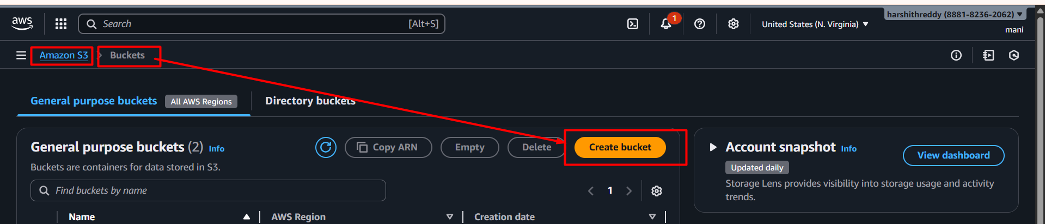

* Choose bucket type “general purpose” and provide a unique name for the bucket

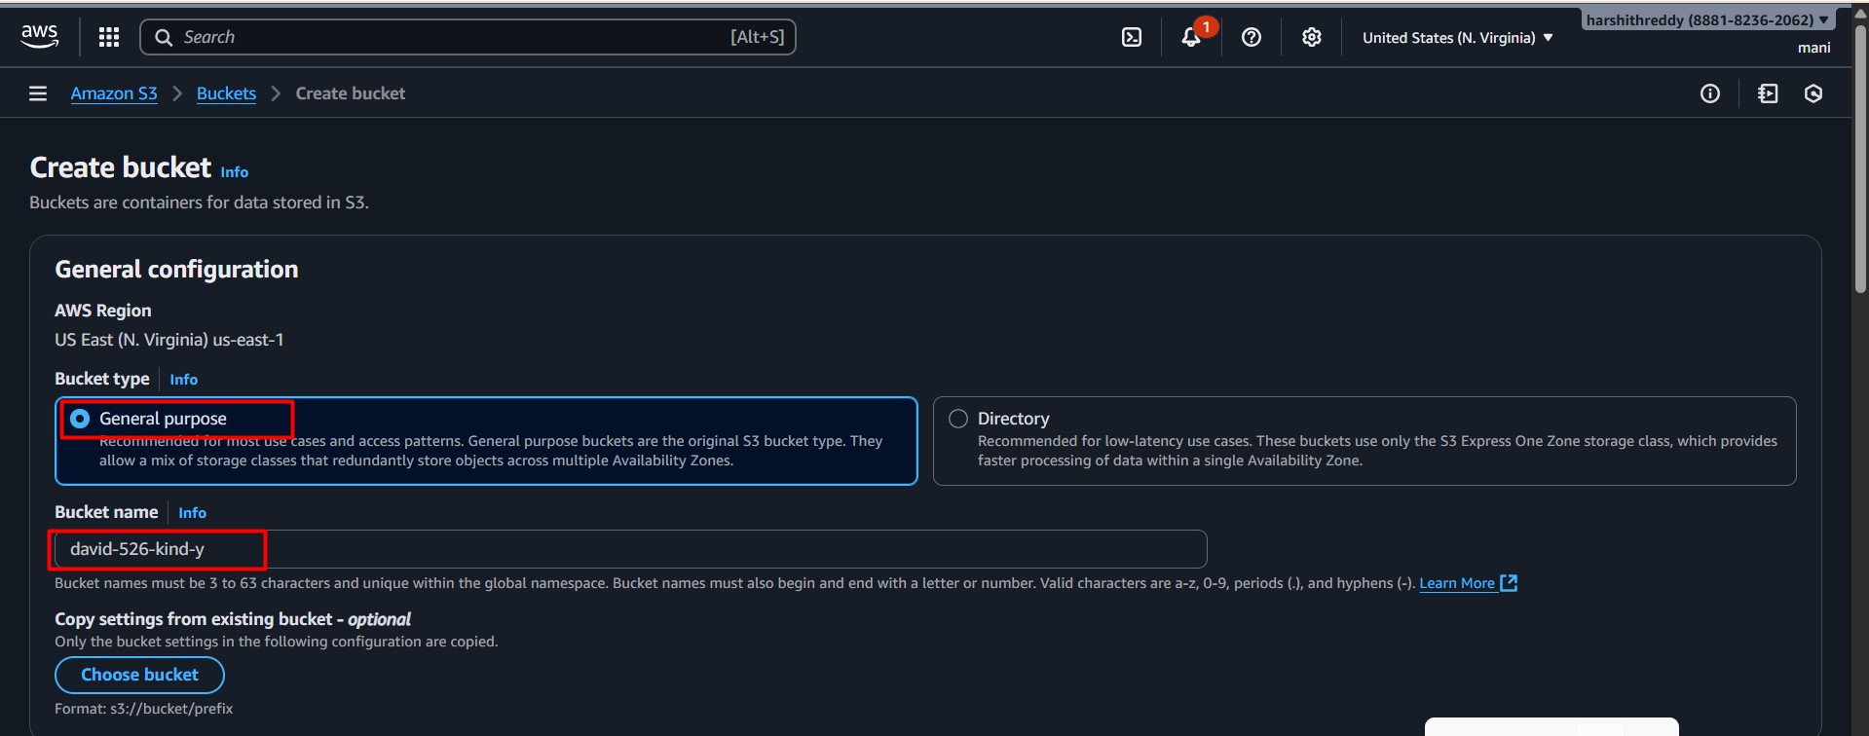

* Ownership choose ACL’s disabled and unblock public access and confirm acknowledge

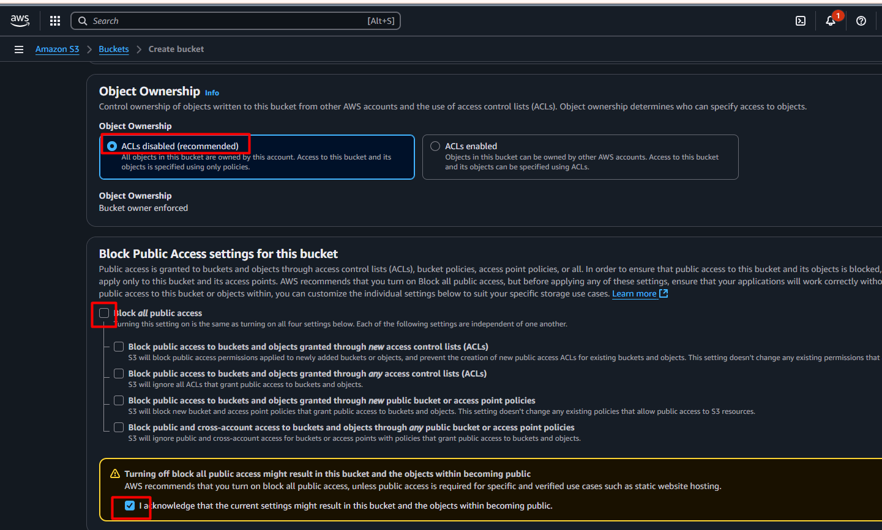

* Select following options after click on create bucket

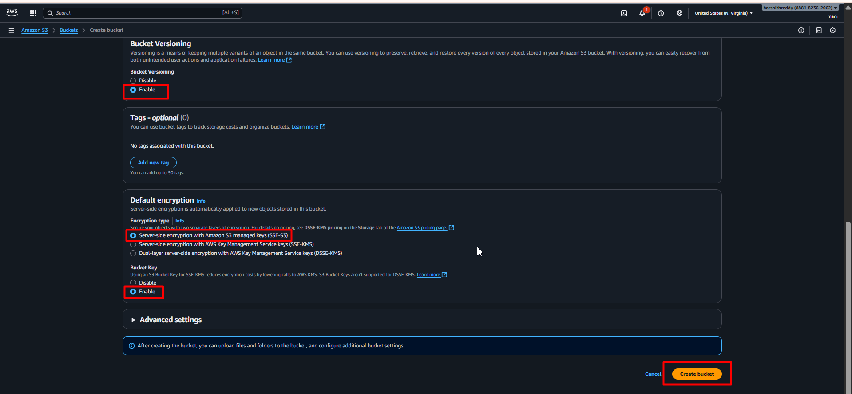

* Bucket created successfully

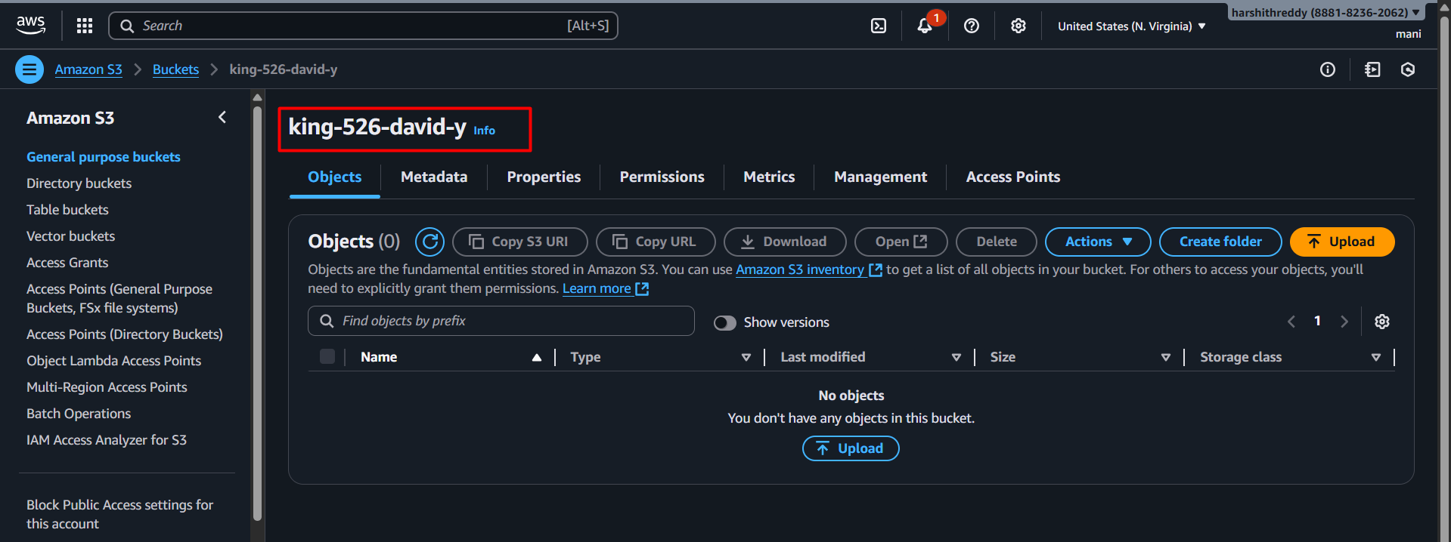

* Create a folder in bucket

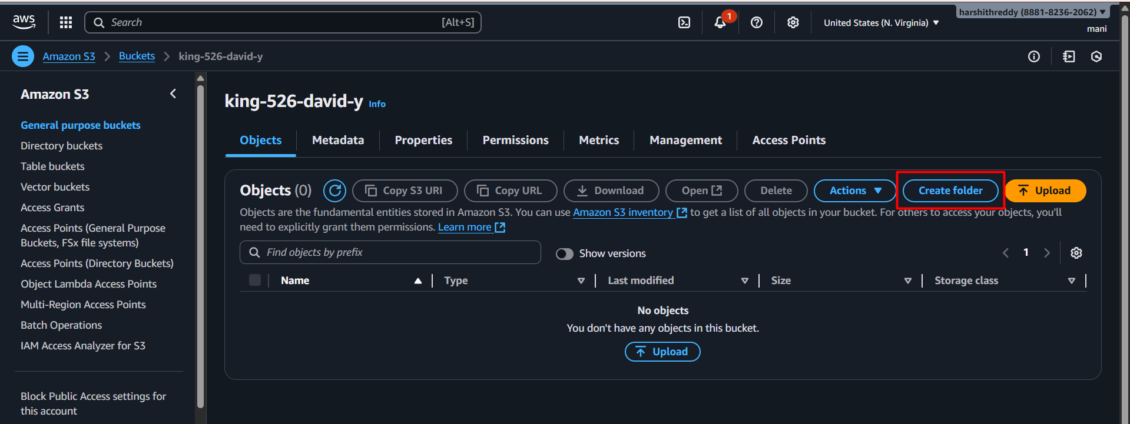

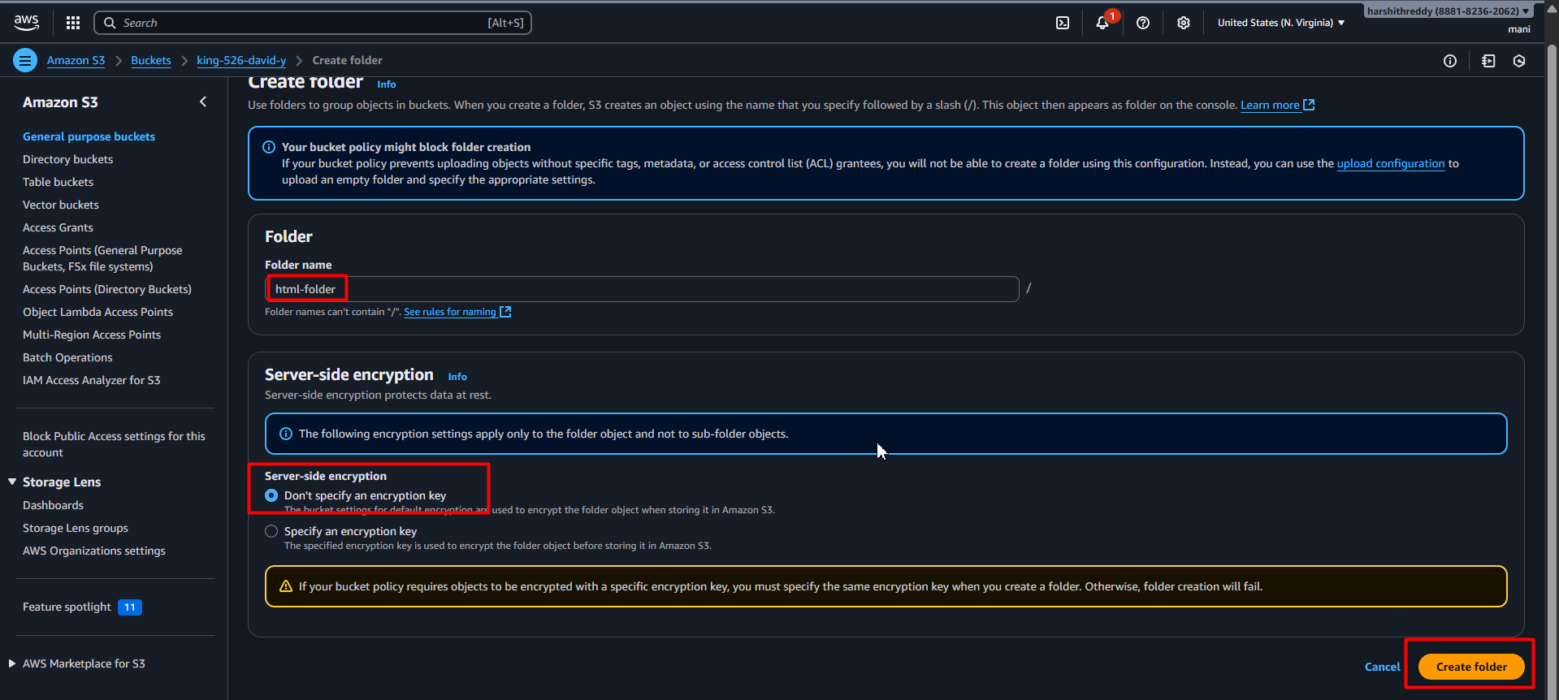

* Folder created named html-folder

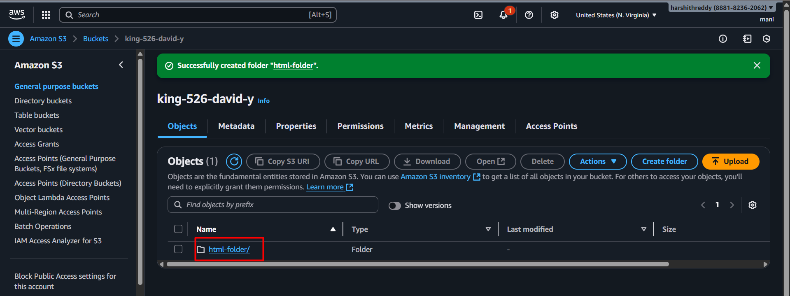

* Let’s, get html login page source code from w3 schools 👇

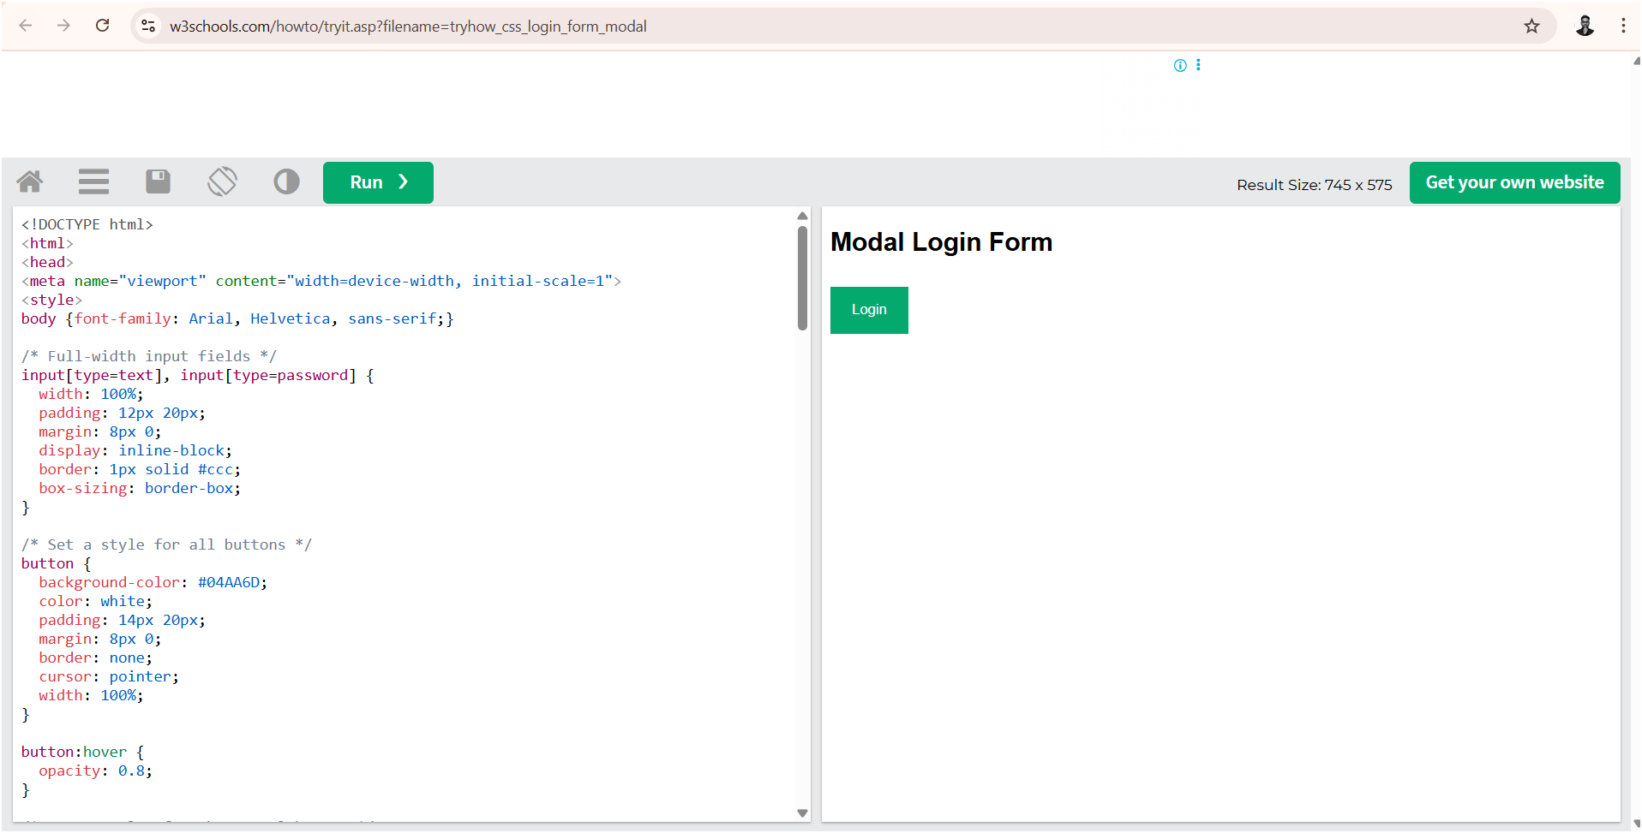

* Create a file named index.html in ur local server and paste the above code inside the file

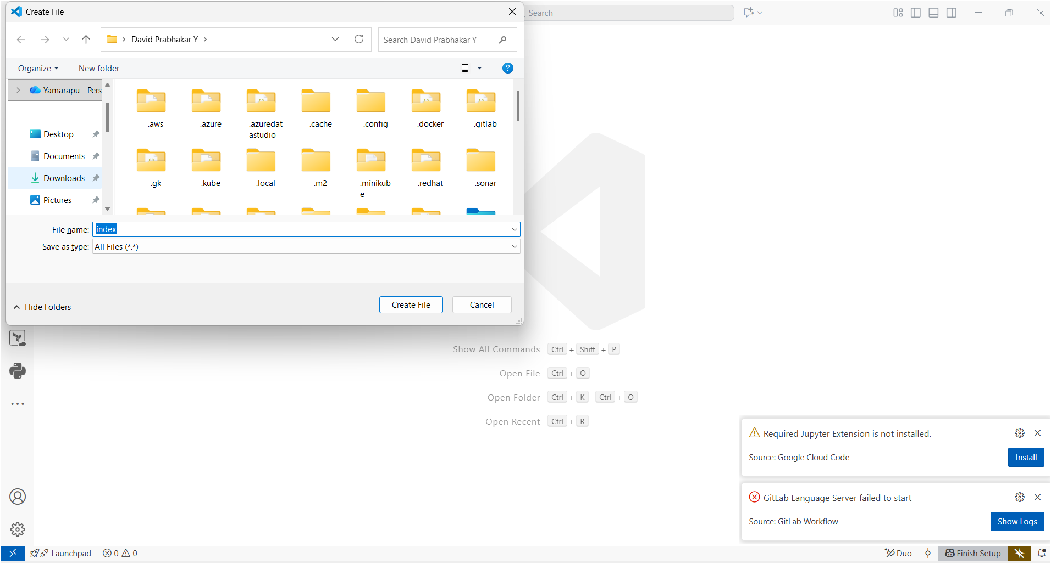

* Provided code in index.html file

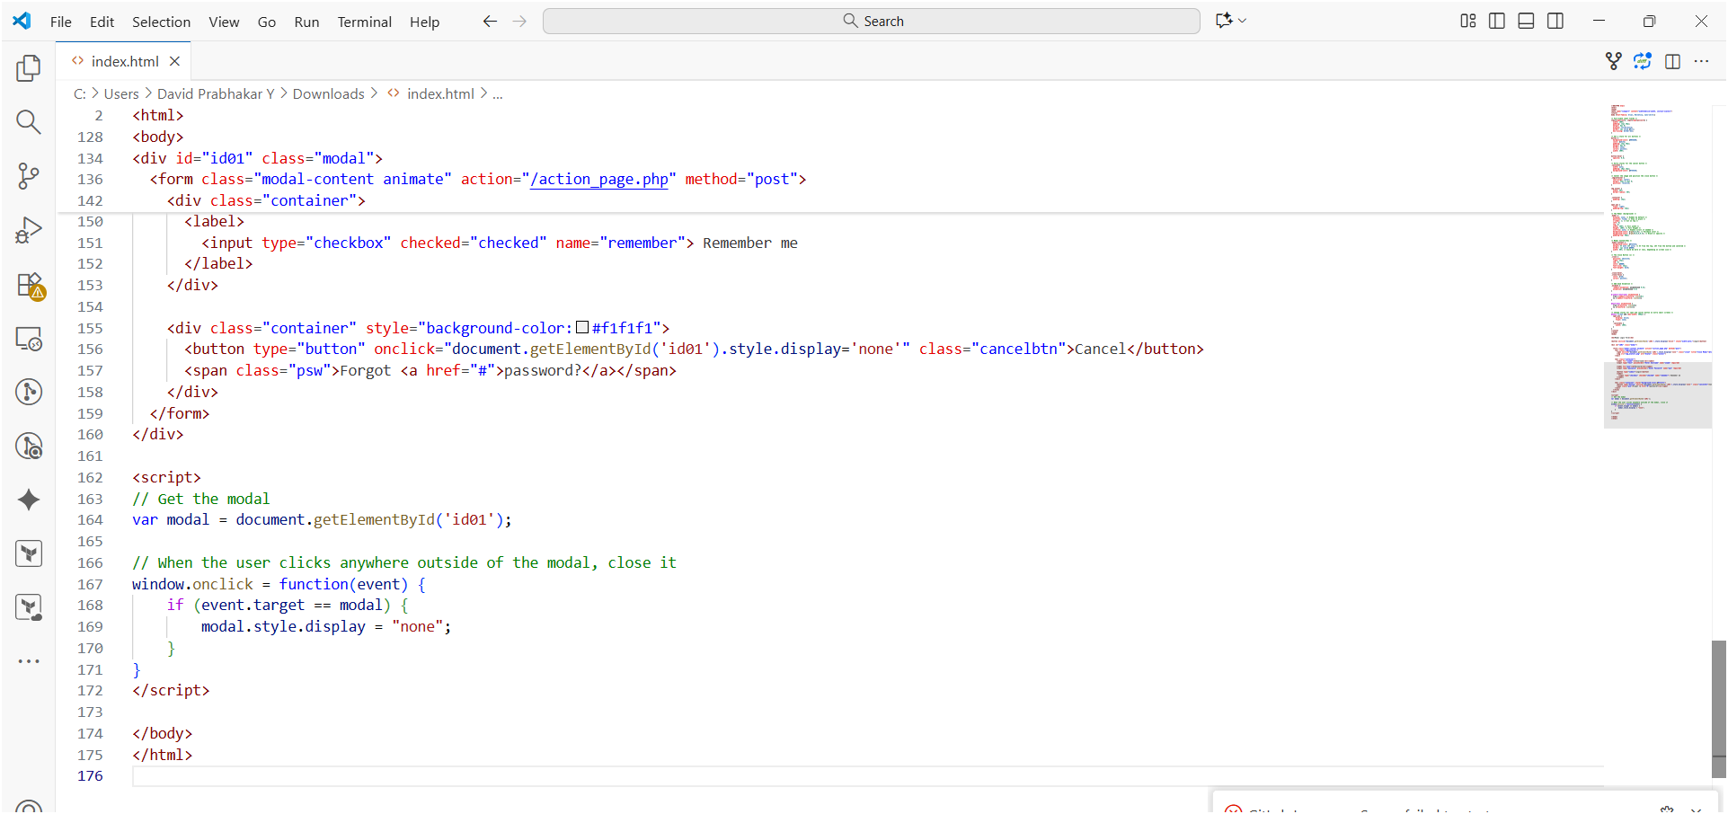

* Next upload this file into s3 bucket 👇

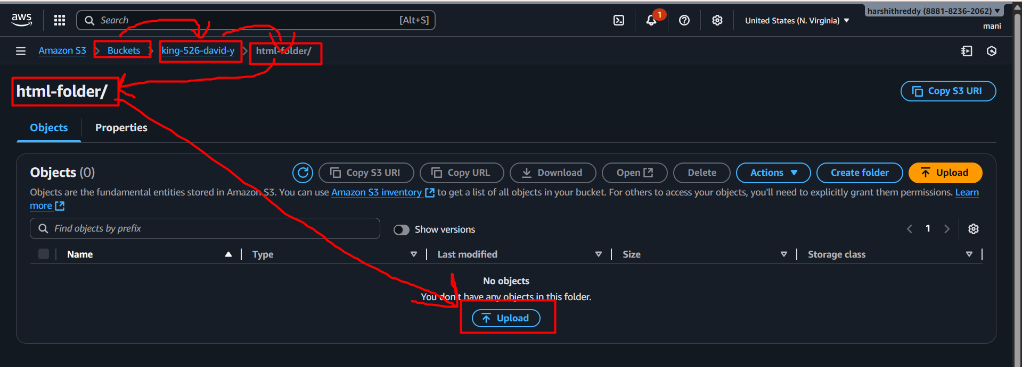

* Click on add file

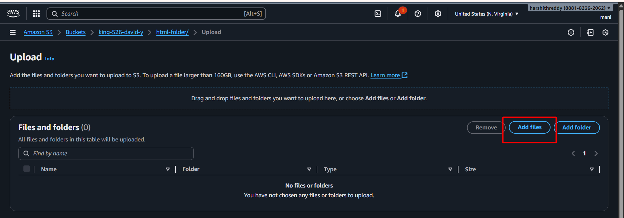

* Choose ur index.html file and upload it 👇

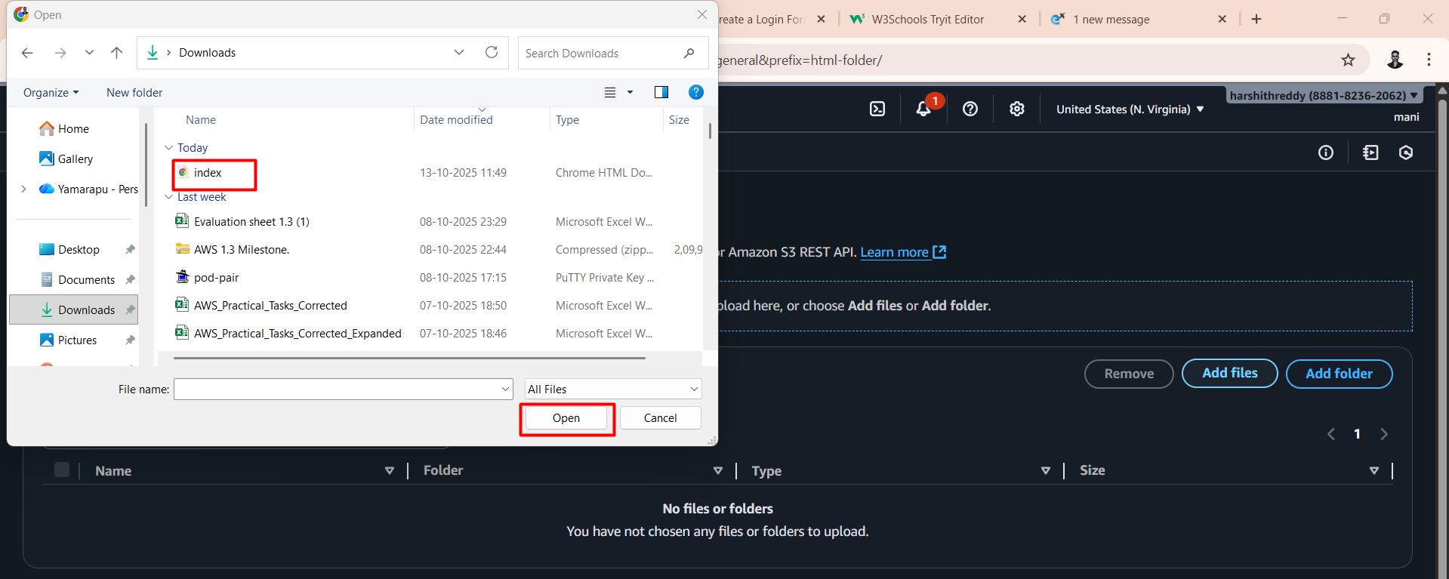

* Click on upload

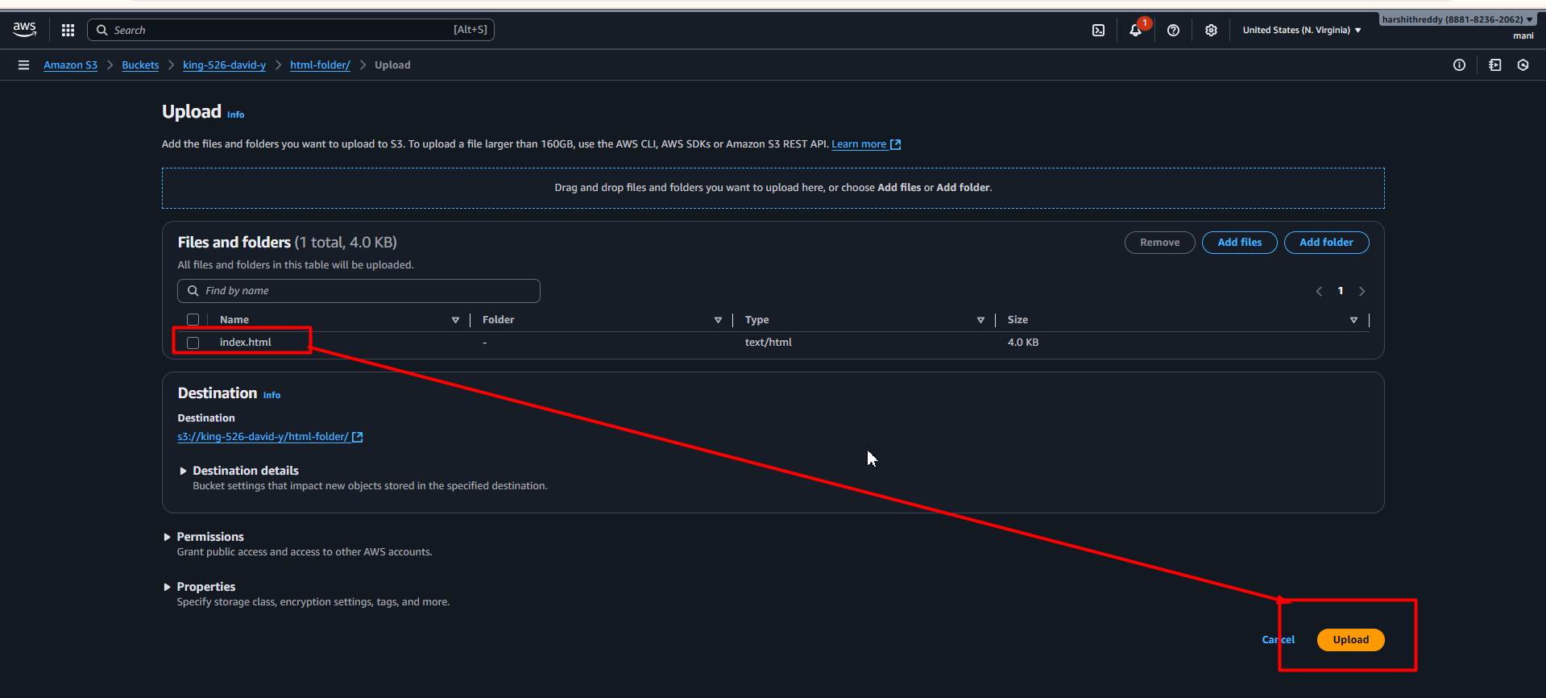

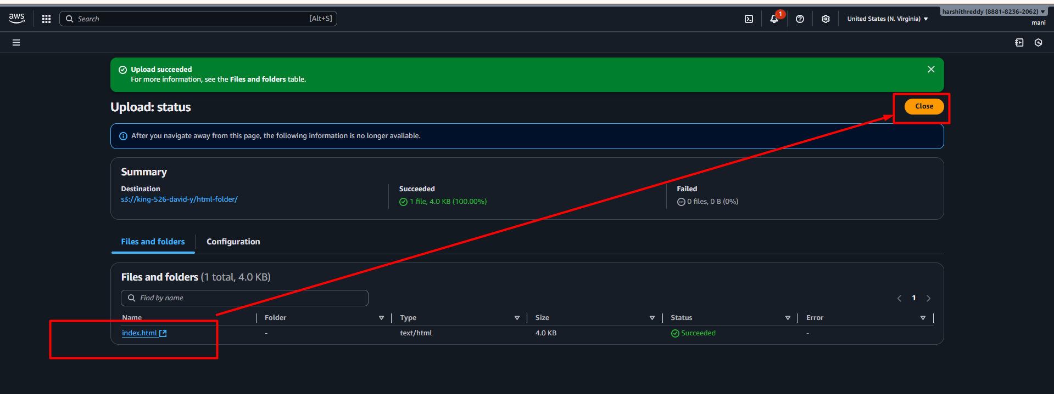

* Next, we have to enable **Static website hosting** 👇

Bucket > object > properties

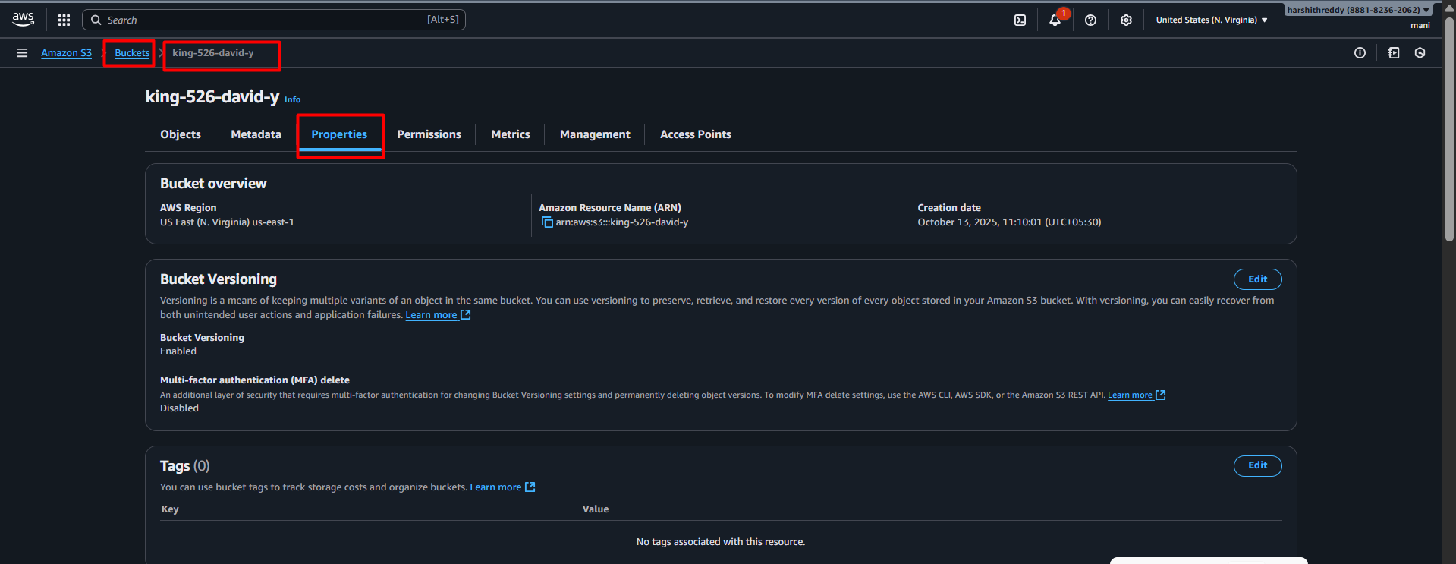

* Scroll down to **Static website hosting on properties tab**

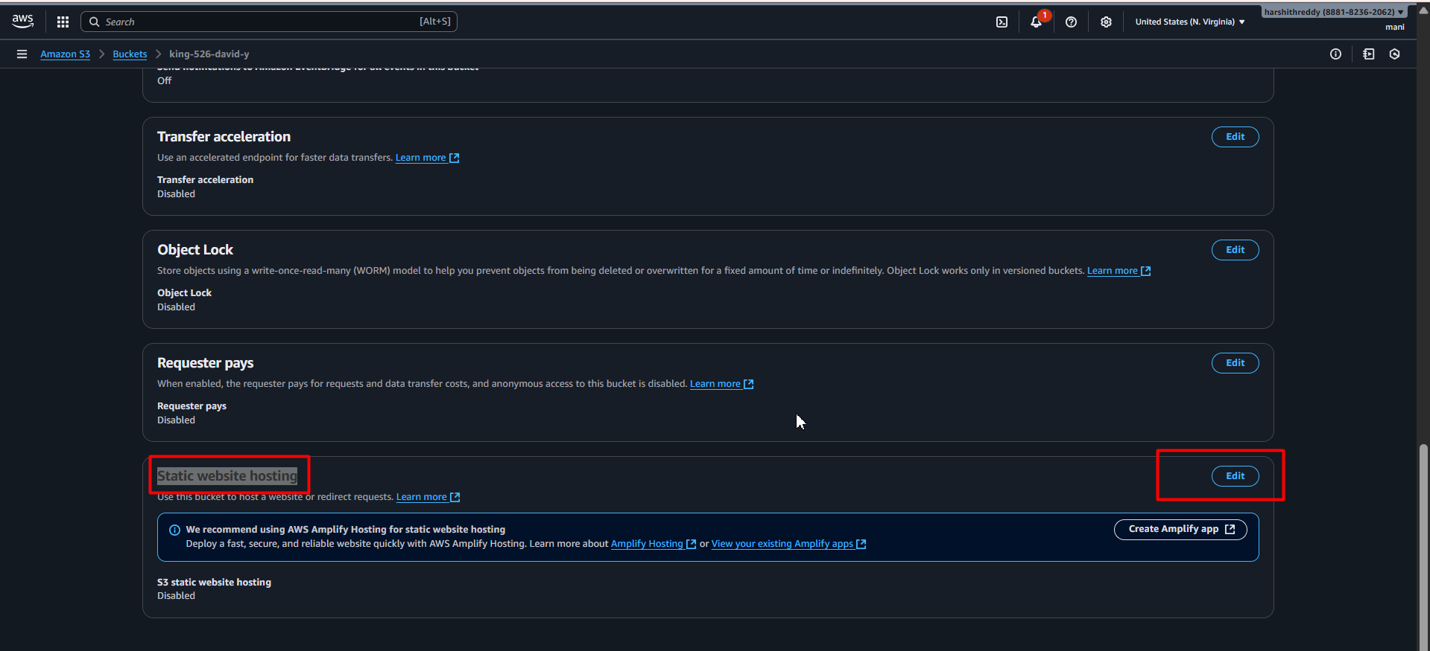

* Click on edit and enable the option

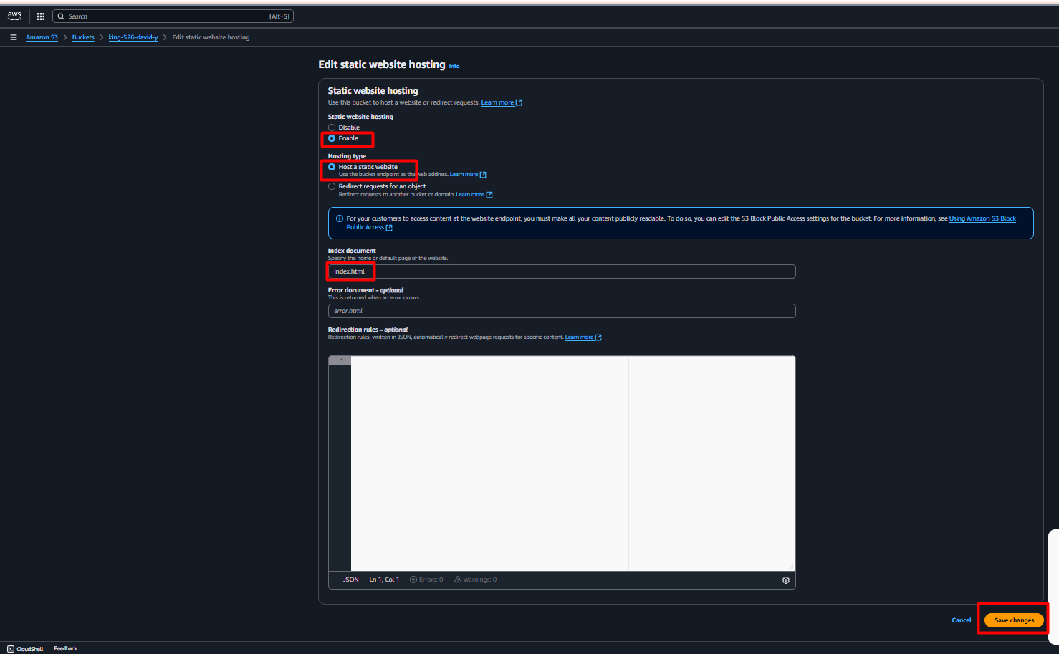

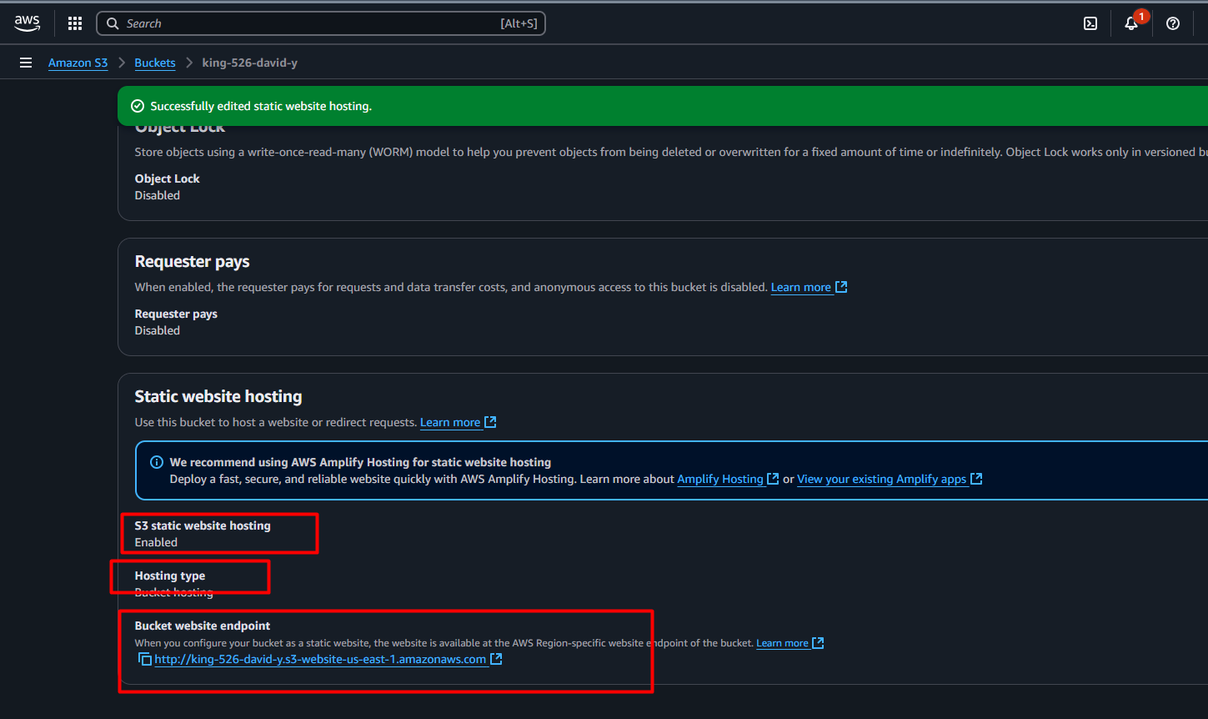

* Next, we have to provide bucket policy to access the app publicly
* Following policy provide in bucket policy section as follows 👇
* Make sure provide ur actual bucket name in the policy

{

"Version": "2012-10-17",

"Statement": [

{

"Sid": "PublicReadGetObject",

"Effect": "Allow",

"Principal": "*",

"Action": "s3:GetObject",

"Resource": "arn:aws:s3:::king-526-david/*"

}

]

}

* Go to bucket policy click on edit

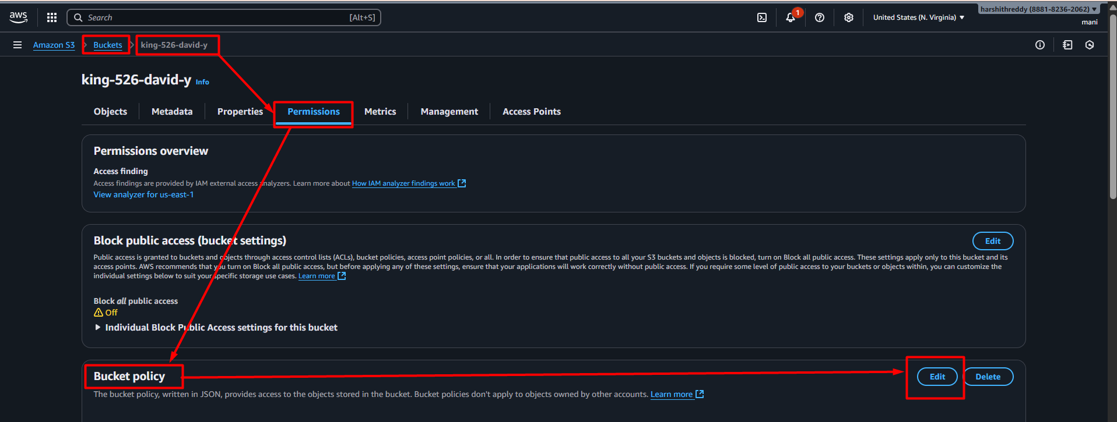

* After providing policy click on save changes

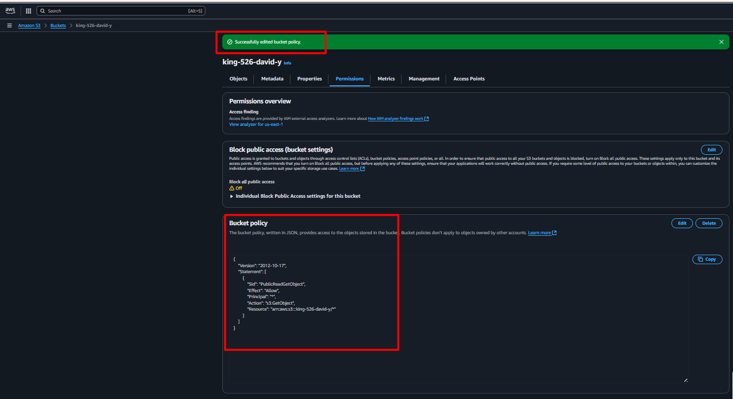

* Now how to access the application follow the below steps 👇

Bucket > folder name > index.html > properties > look for object URL 👇

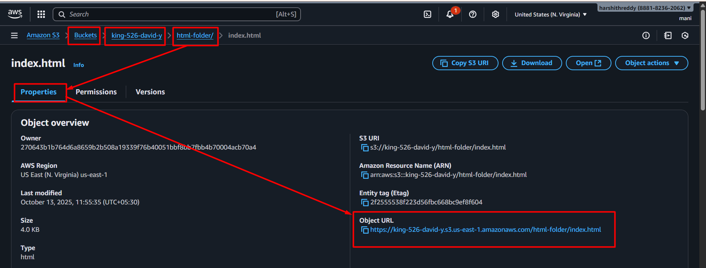

* Copy the URL and paste on browser access the web page

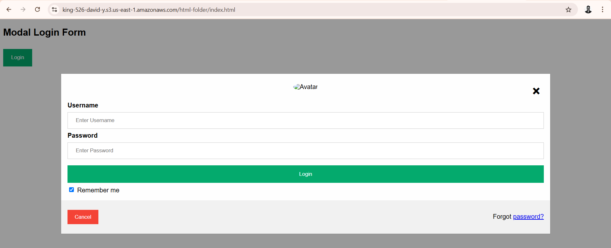

* For suppose if you want give access ur app to someone for temporary purpose
* We can use Share **with a presigned URL here we can control access**
* follow the below steps 👇

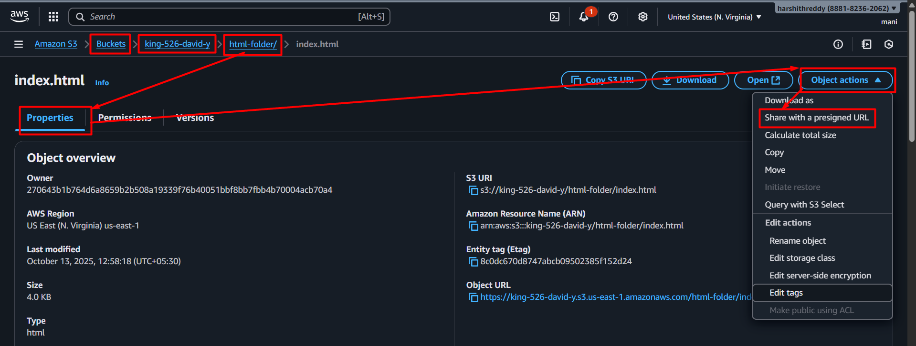

* click on Share **with a presigned URL** 👇

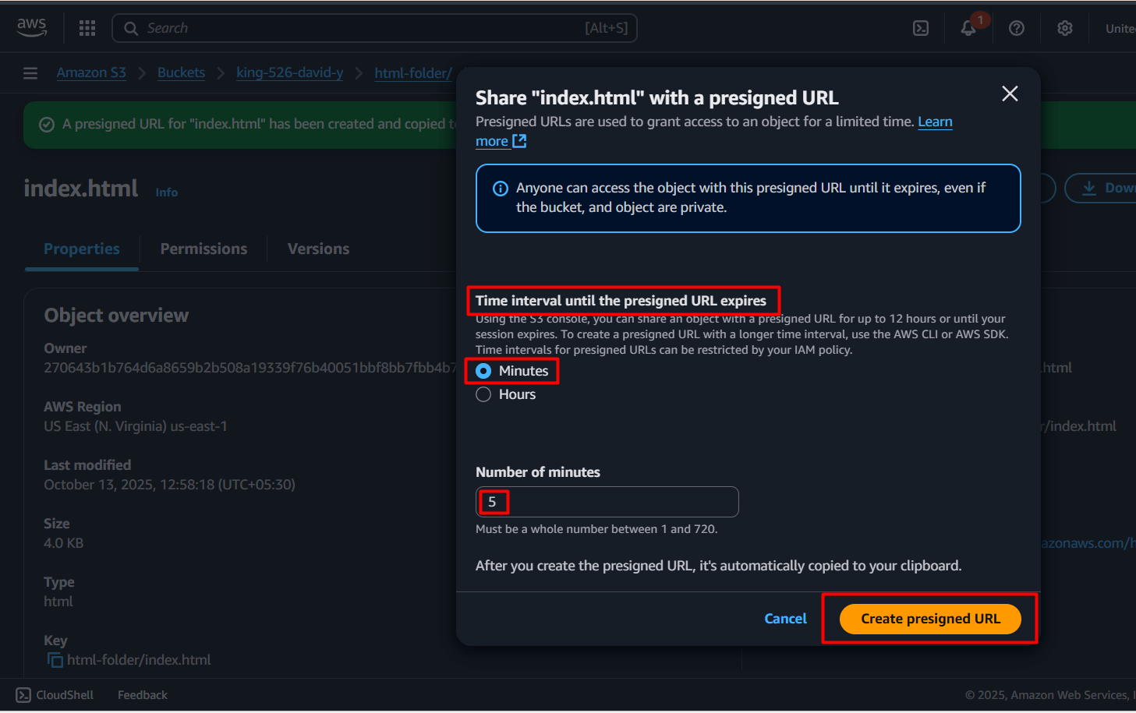

* on top of the screen, you can see one URL you can copy n share that url to someone they can access app utpo 5 mnts after access will be removed (you can change time expiration as much as you want)

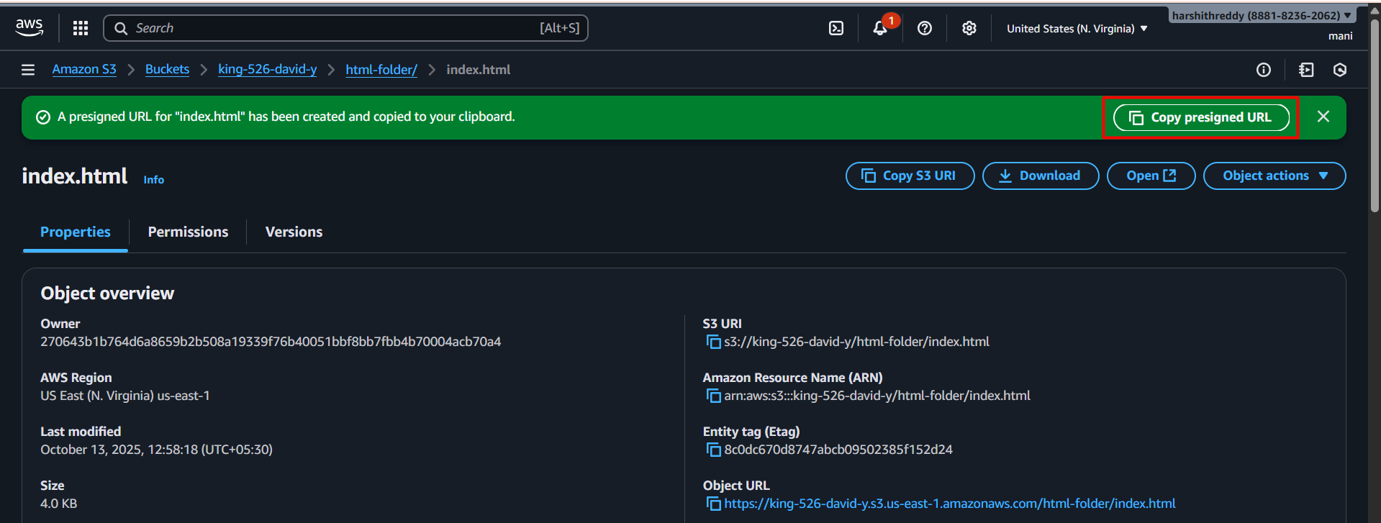

* on browser able to access the app 👇

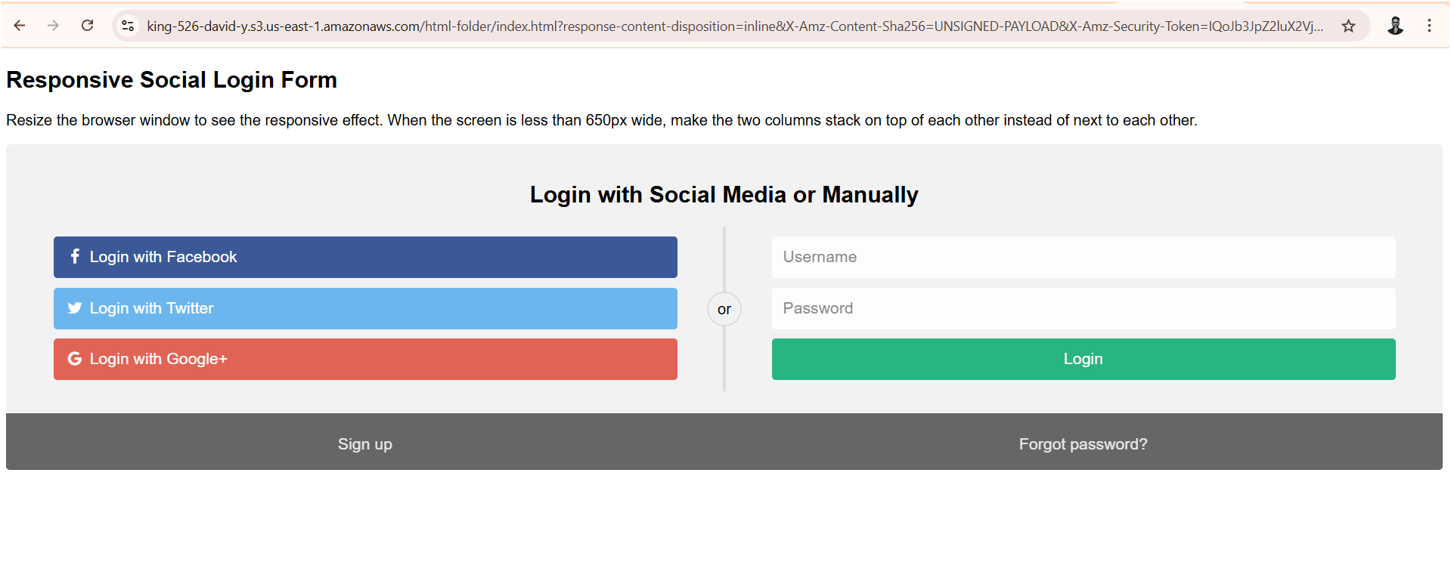

* Above process is called completely manual deployment.
* But we have to automate the deployment process

**GitHub Actions**

* By using GitHub actions follow the below steps 👇

**Prerequisites**

1. App GitHub Repo
2. Aws access keys
3. .github/workflows/deploy.yml file should be created in app root directory

* Let’s create aws access keys 👇

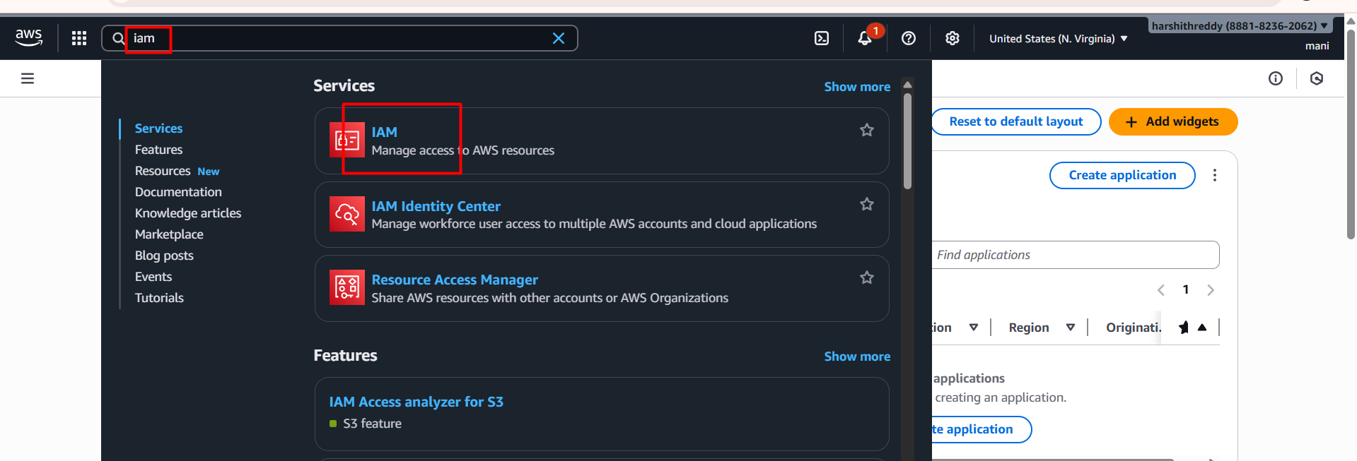

Go to IAM dashboard > click on users > click on create user

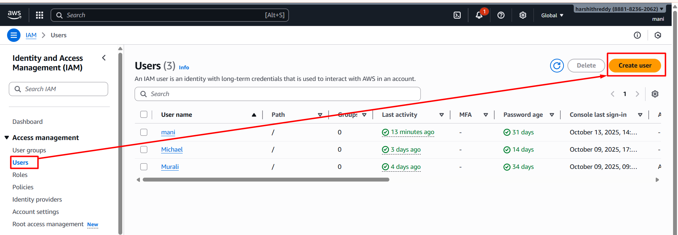

* Provide user name

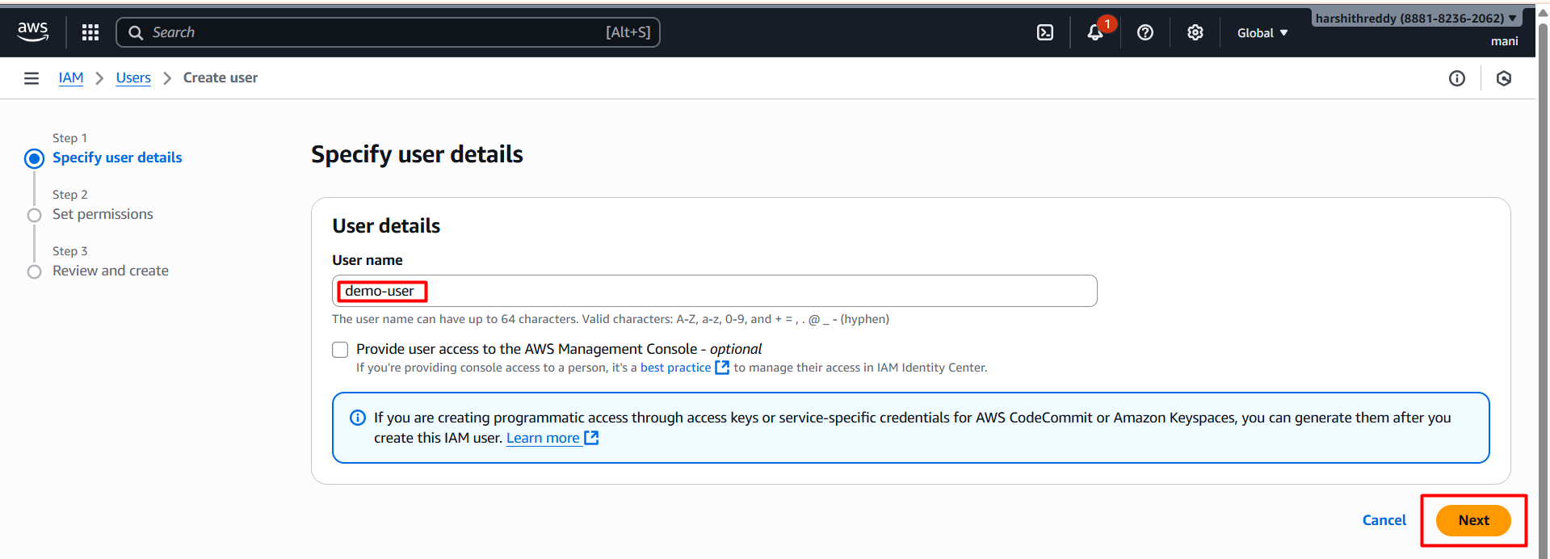

* Select s3 full access policy 👇

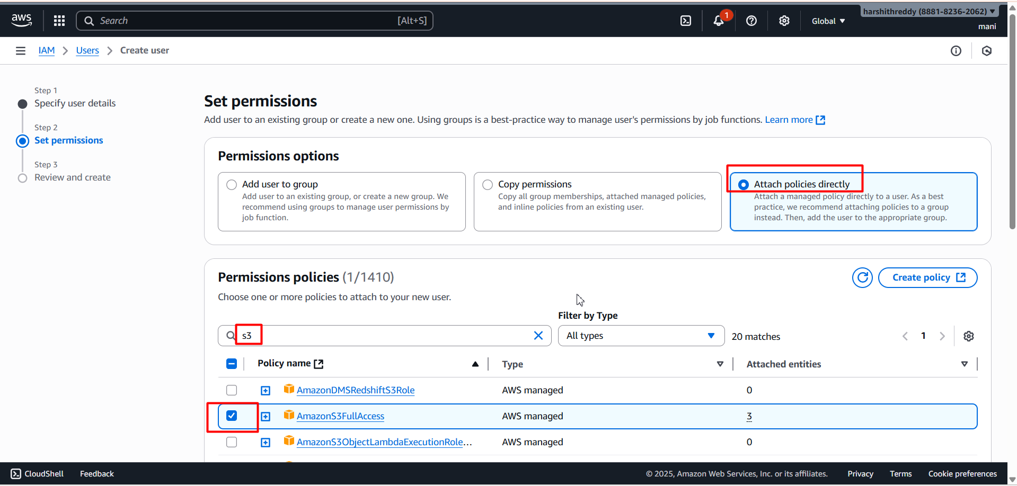

* Click on next

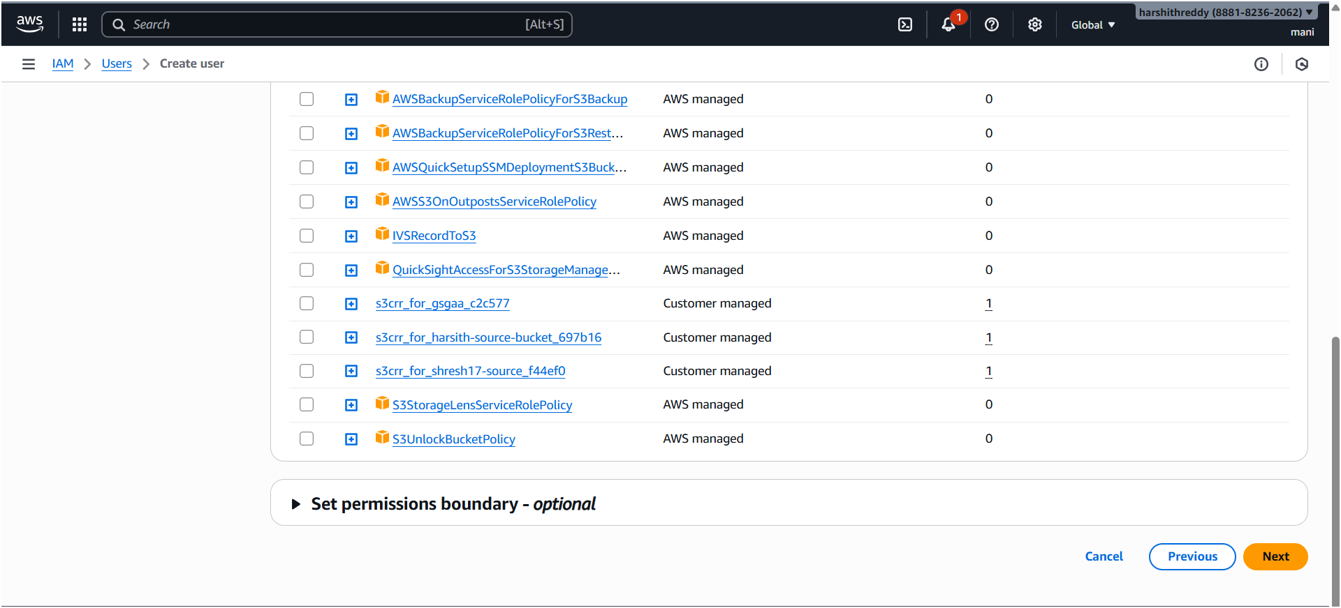

* Review and click on

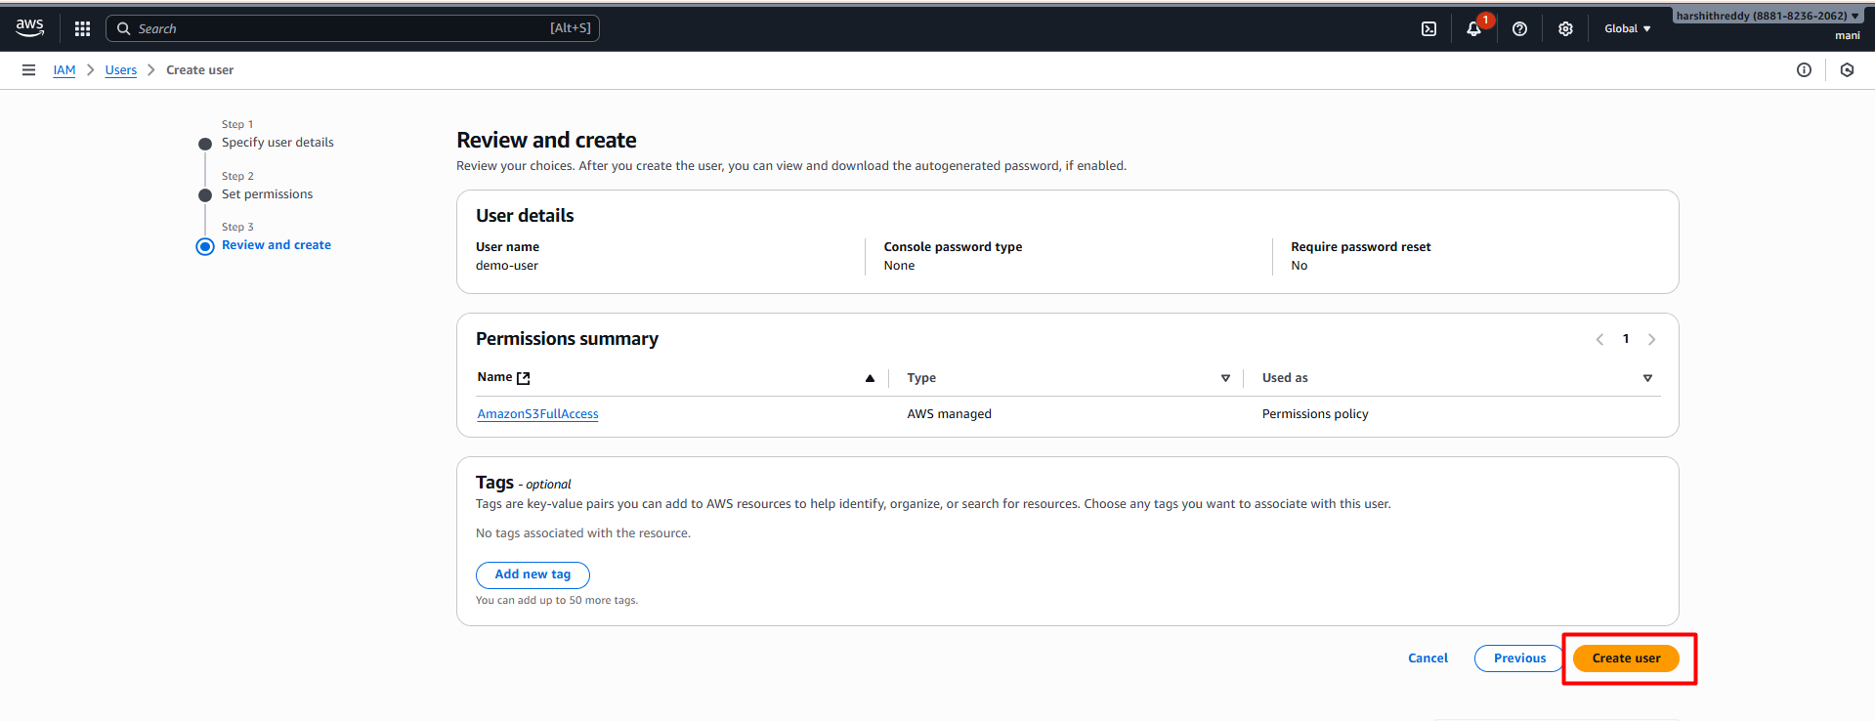

* Click on view user

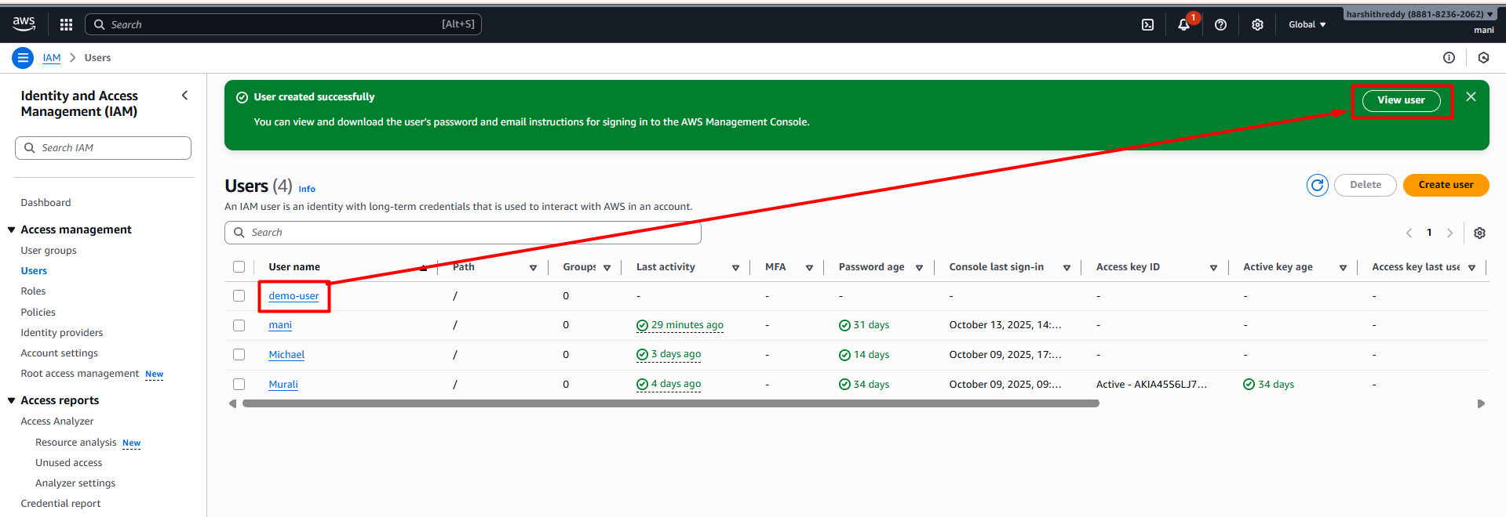

* Click on create access keys

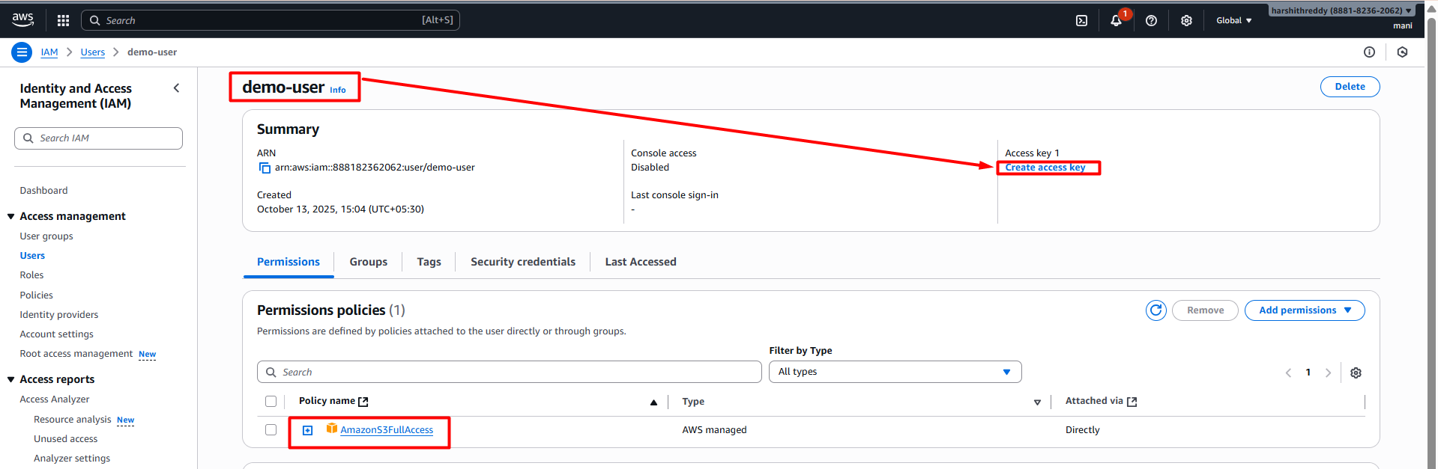

* Select use case applications running outside aws and click on next

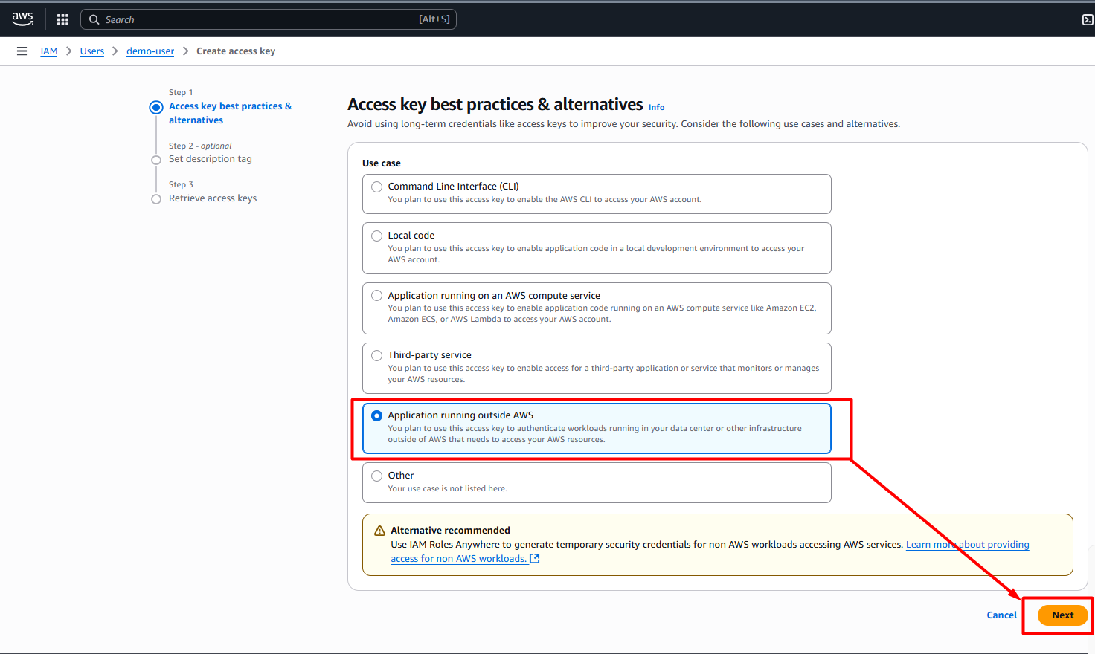

* Click on create access keys

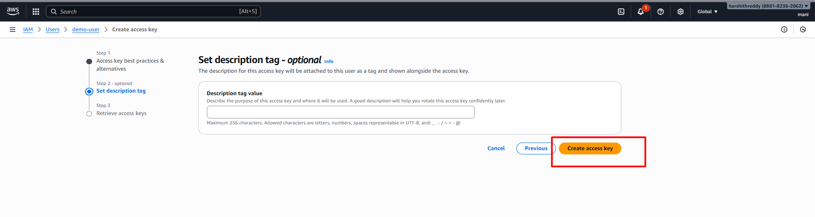

* Click on download .csv to download into local server

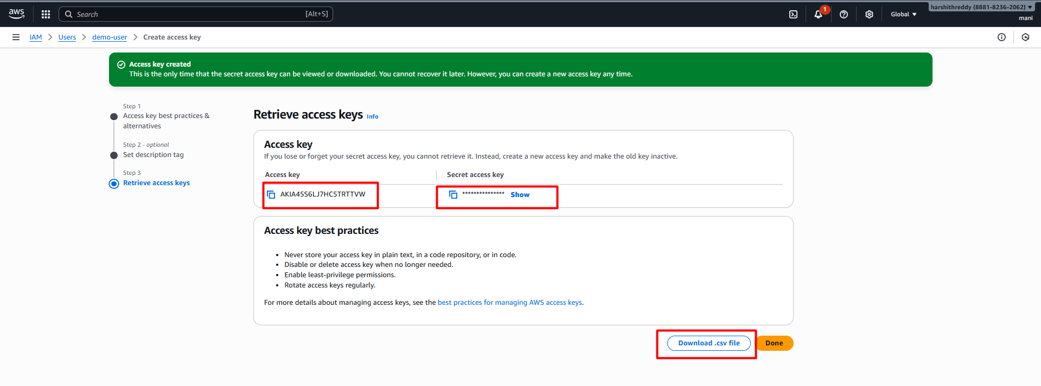

* Next, we have to configure these aws access keys into GitHub secrets 👇

Go to your GitHub repository.

Navigate to:

Settings → Secrets and variables → Actions

Under Repository secrets,

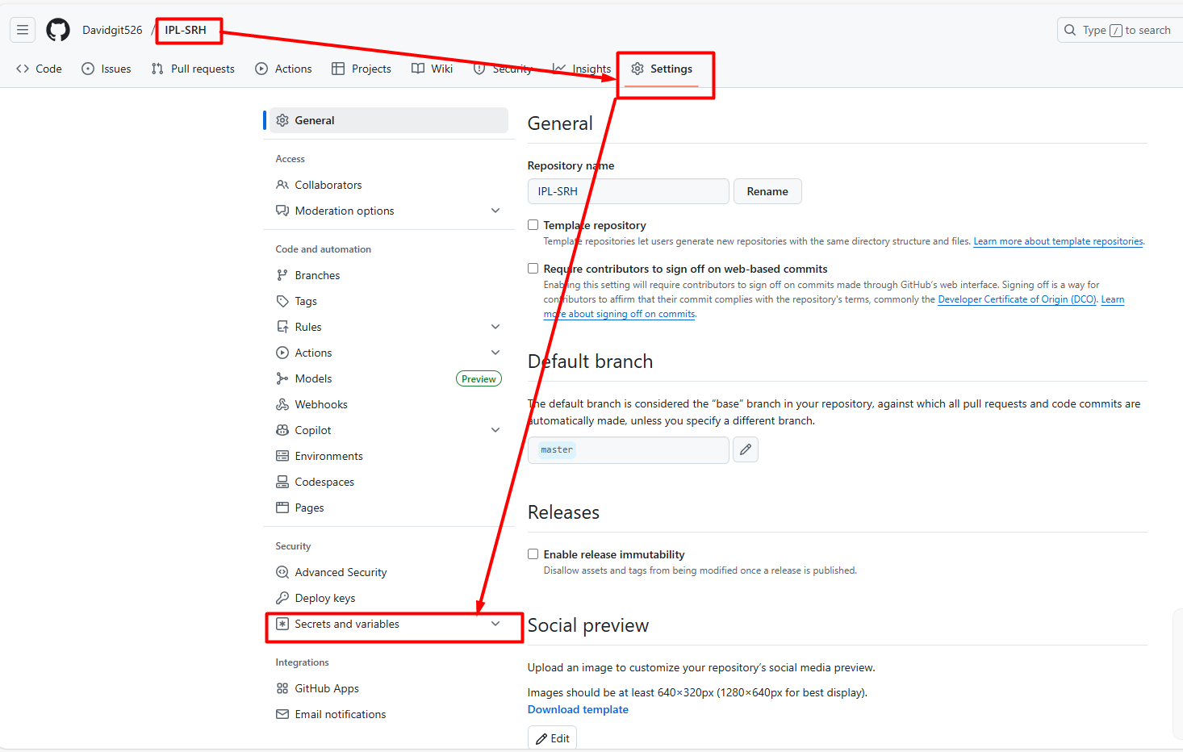

* Click on secret and variables

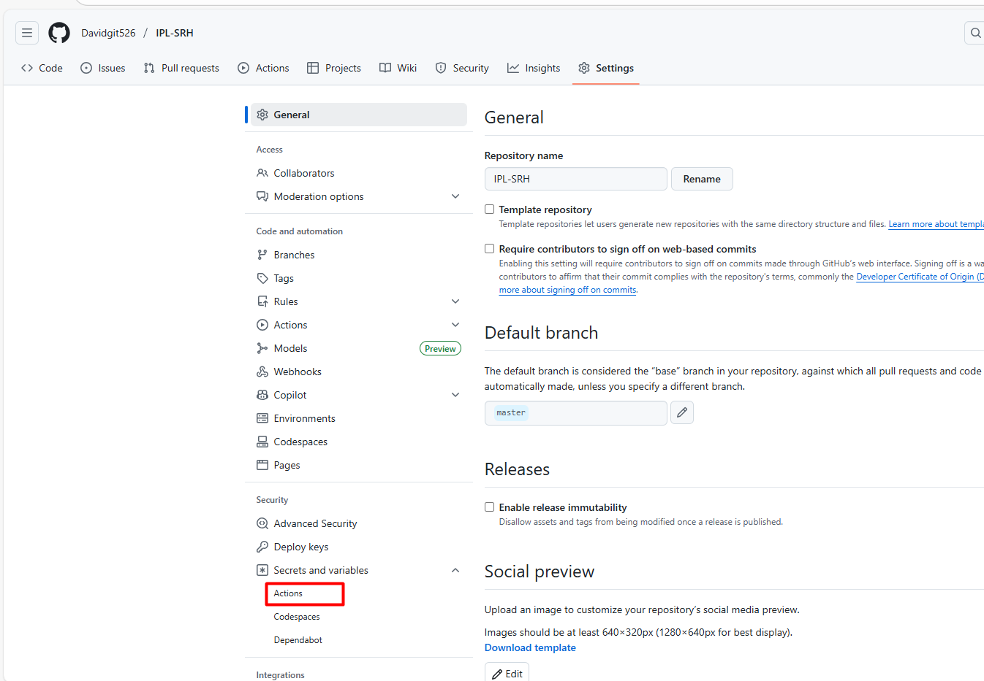

* Click on actions

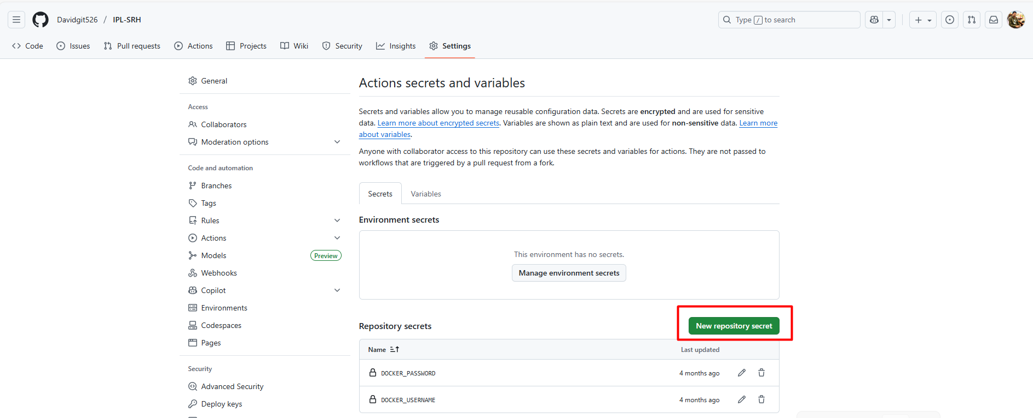

* Click on new repository secrets

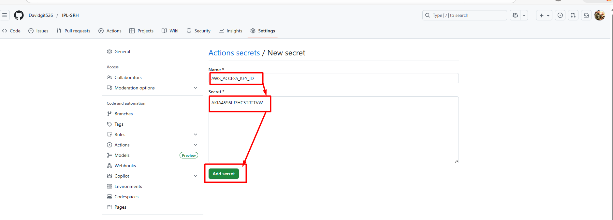

* Aws access key id added as a Secrete

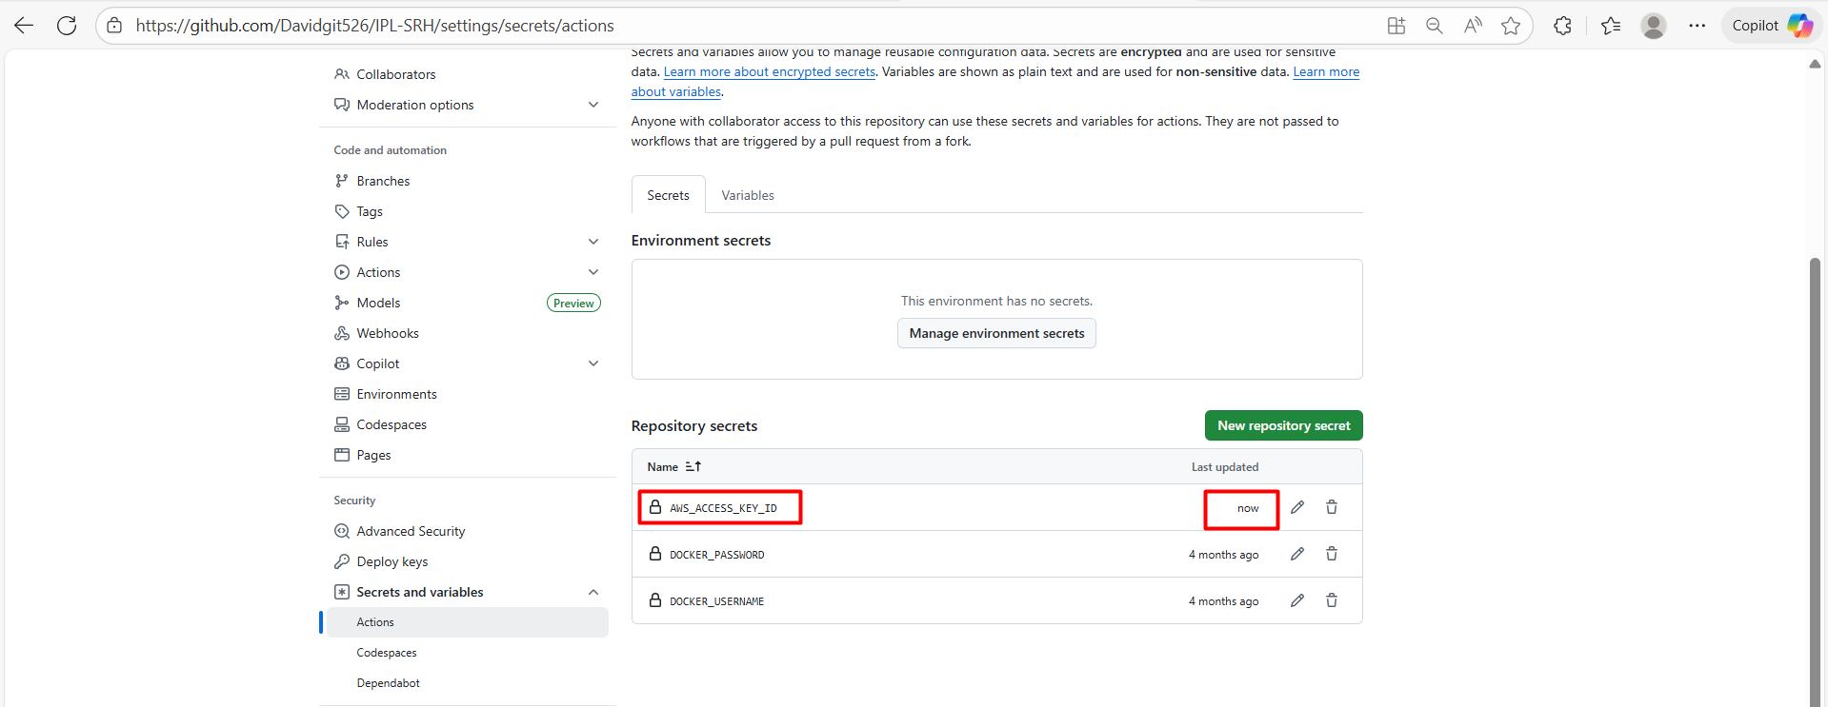

* Aws secret key id added as a secret

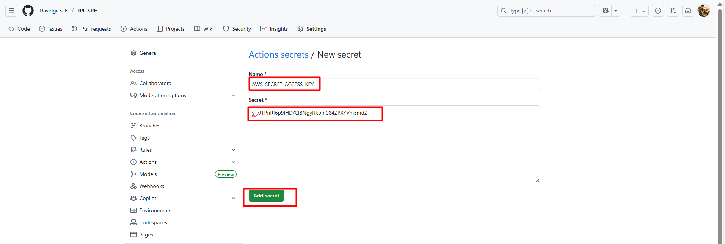

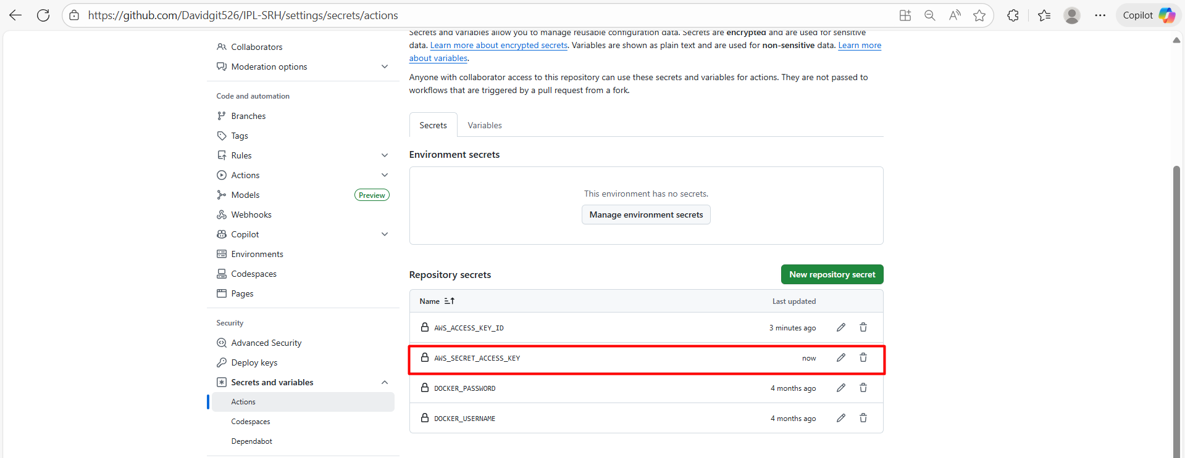

* Aws region added as a secret

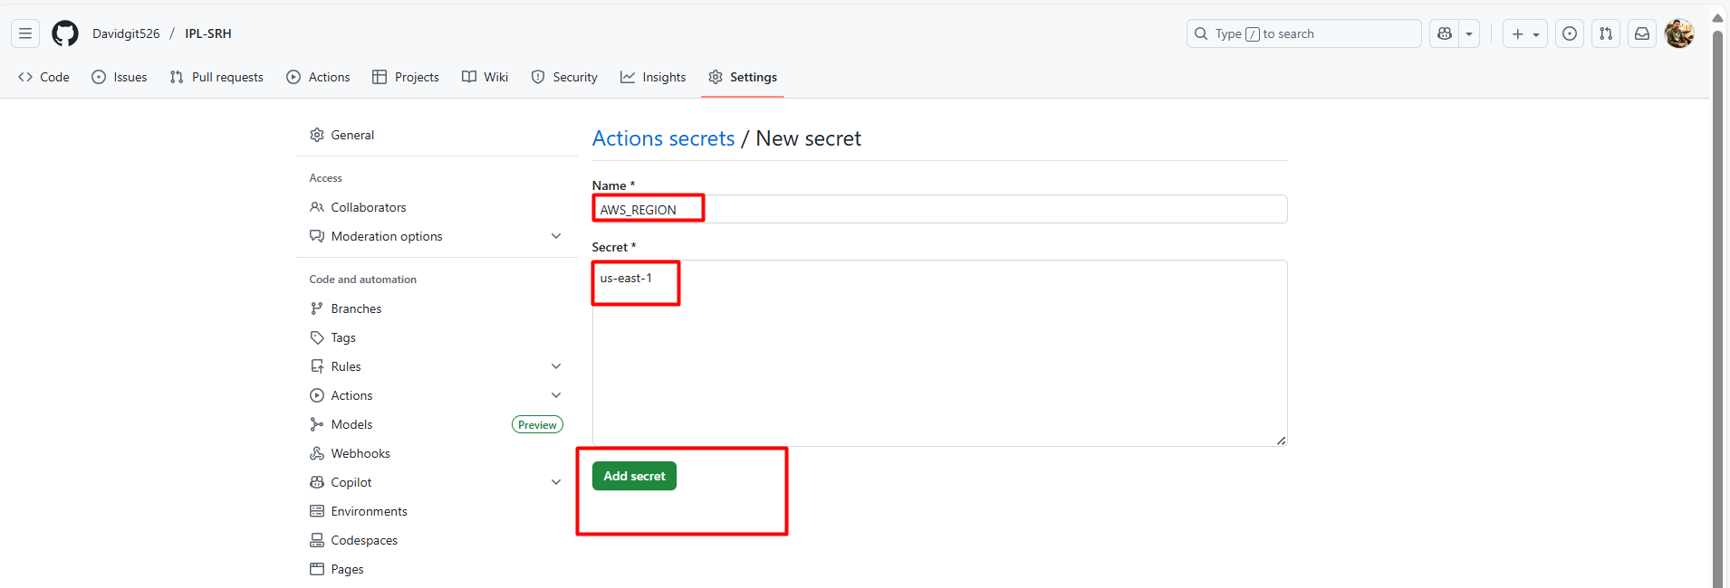

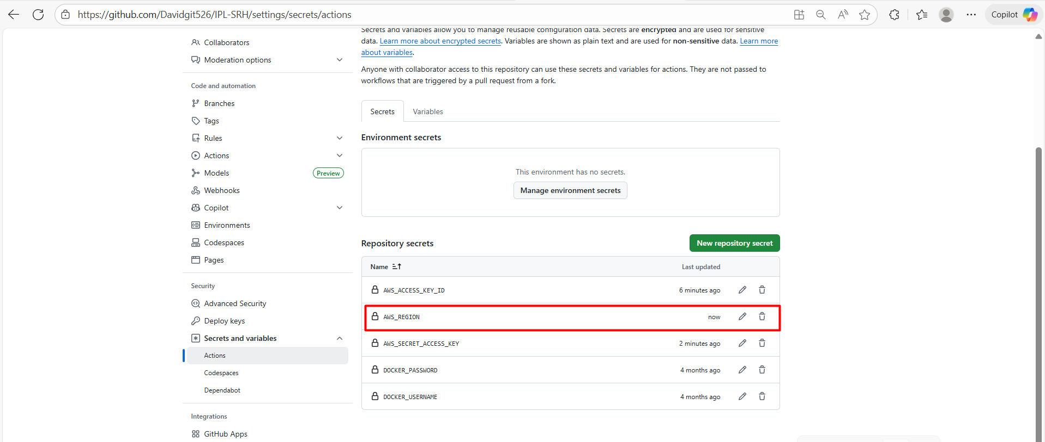

* Added bucket name as a secret

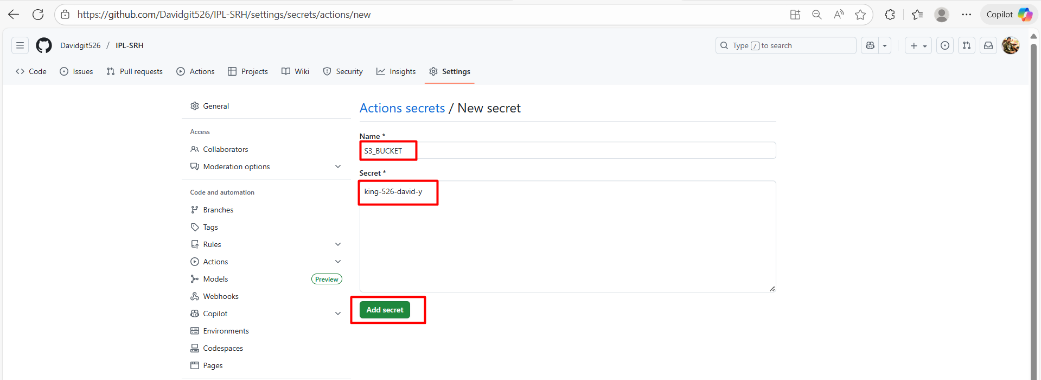

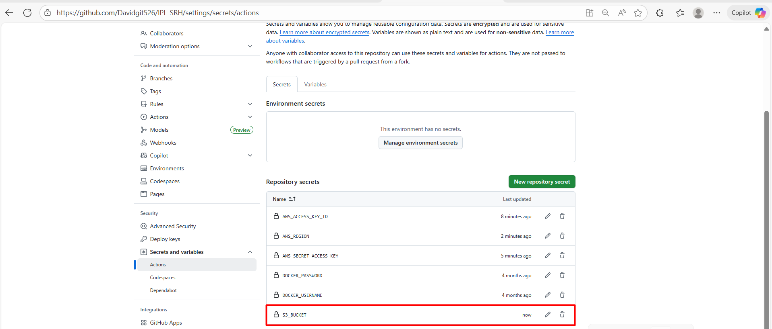

* Required credentials have been added in GitHub repo secrets

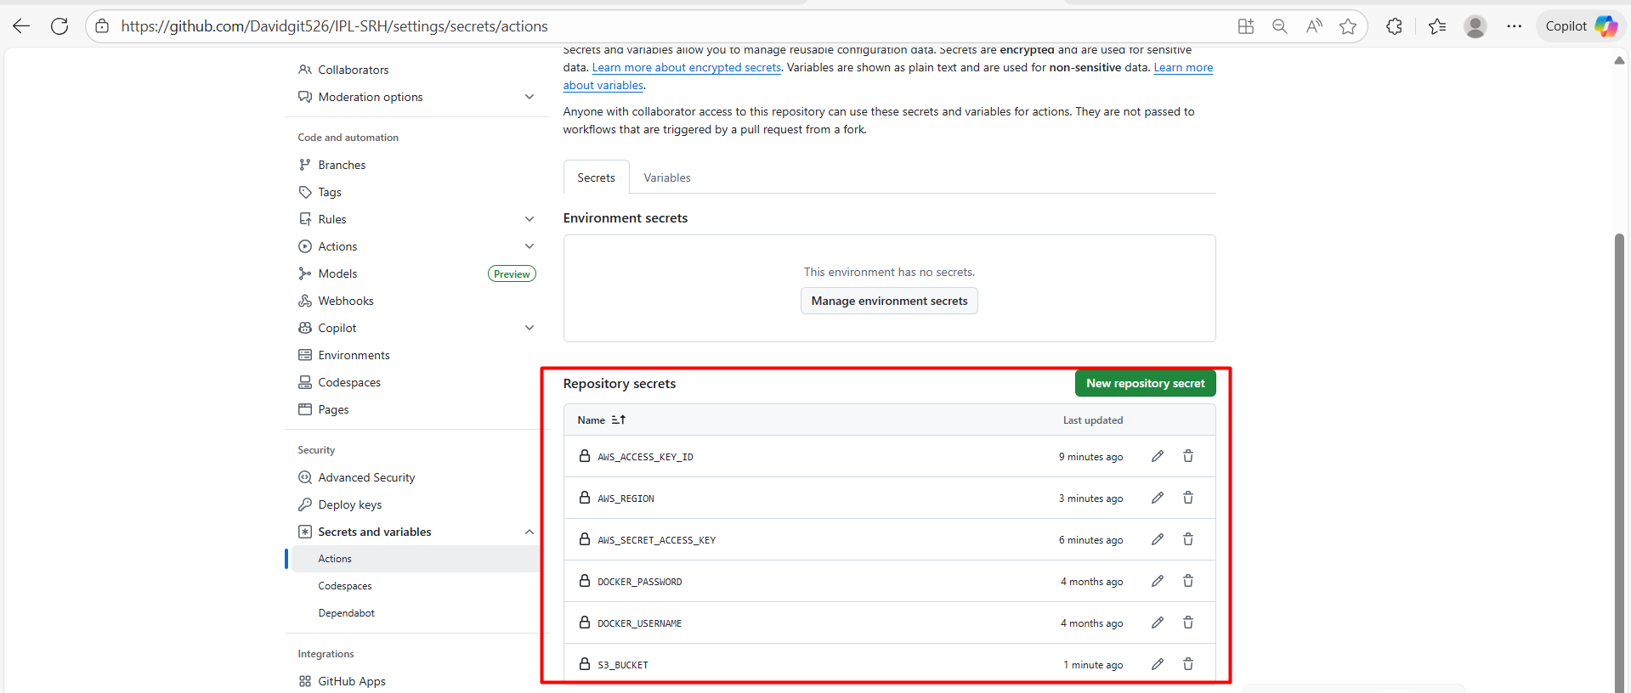

* Next in app Repo need to create file named “.github/workflows/deploy.yml”
* Follow the below steps
* Go to GitHub repo and open any file in github.dev mode after you will get vscode window there we can create files and folders 👇

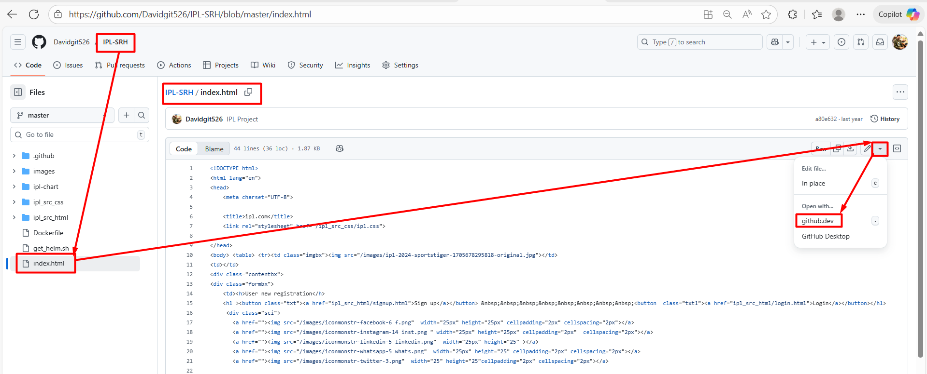

* File created and pasted script

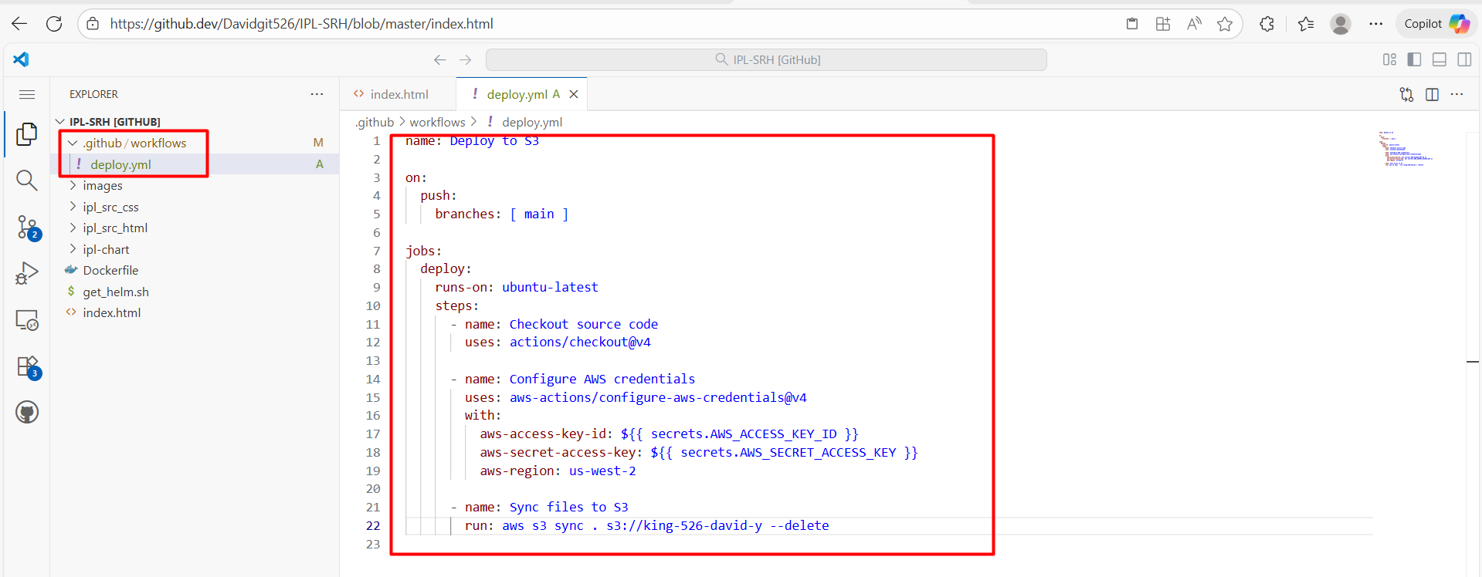

* This is script for ci in GitHub actions

name: Deploy to S3

on:

push:

branches: [ master ] # make sure correct branch name

jobs:

deploy:

runs-on: ubuntu-latest

steps:

- name: Checkout source code

uses: actions/checkout@v4

- name: Configure AWS credentials

uses: aws-actions/configure-aws-credentials@v4

with:

aws-access-key-id: ${{ secrets.AWS_ACCESS_KEY_ID }}

aws-secret-access-key: ${{ secrets.AWS_SECRET_ACCESS_KEY }}

aws-region: us-west-2 # make sure correct region name

- name: Sync files to S3

run: aws s3 sync . s3://king-526-david-y –delete # make sure correct bucket name

* Push ur changes into remote repo

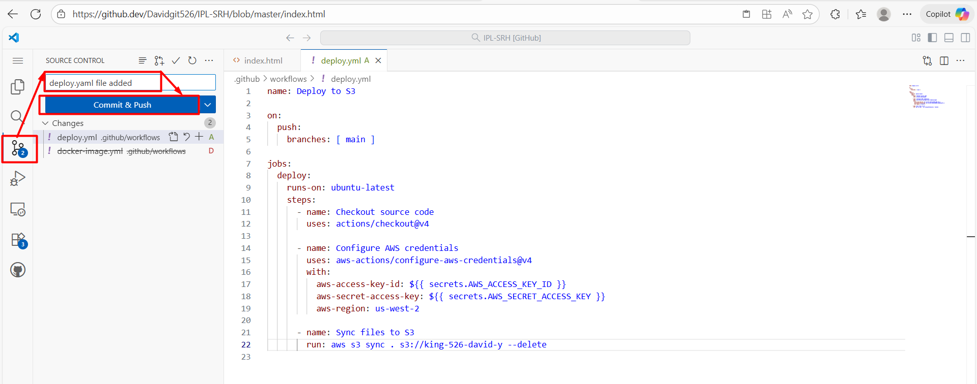

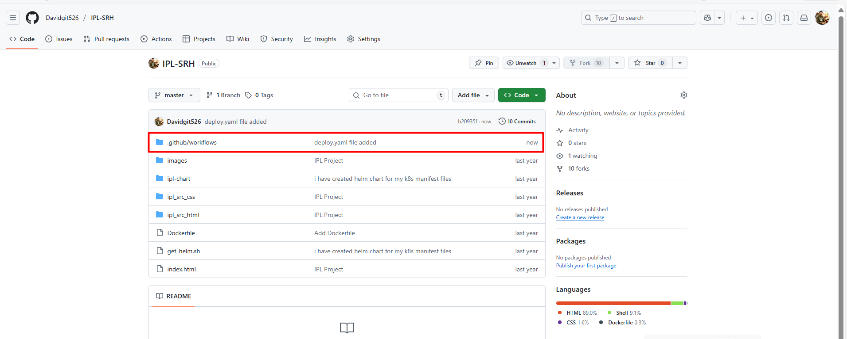

* Now check github action workflow

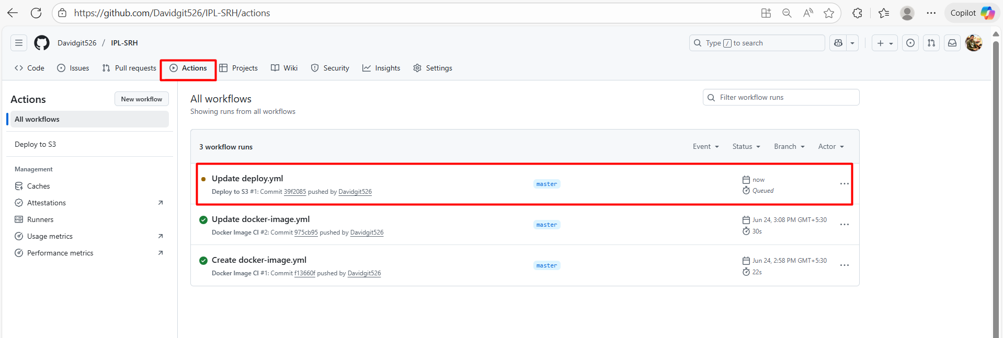

* Look for output

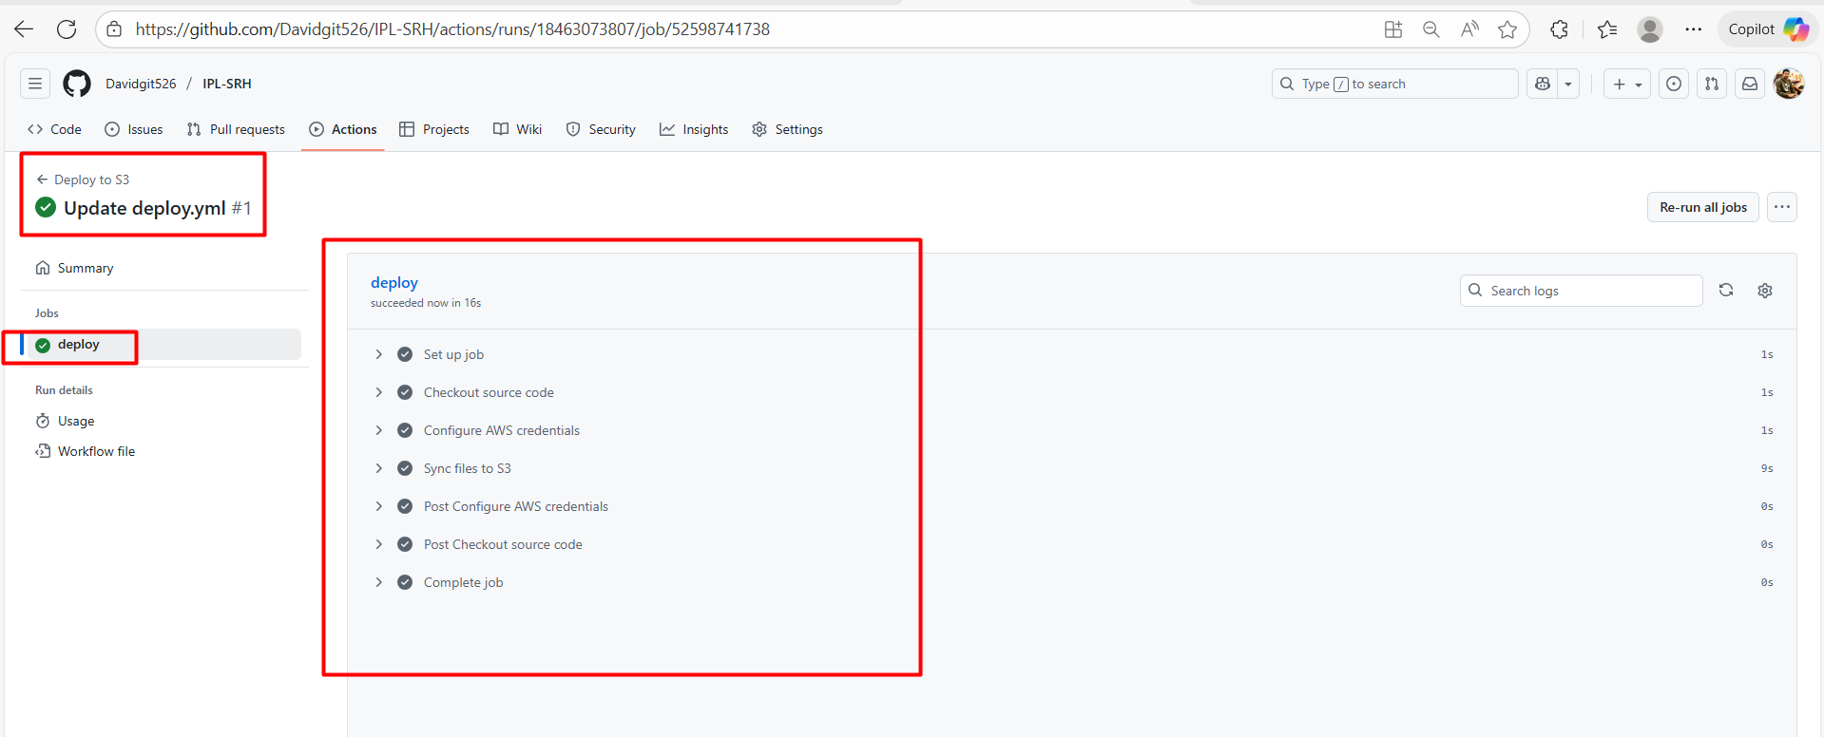

* App repo is deployed into s3 bucket successfully

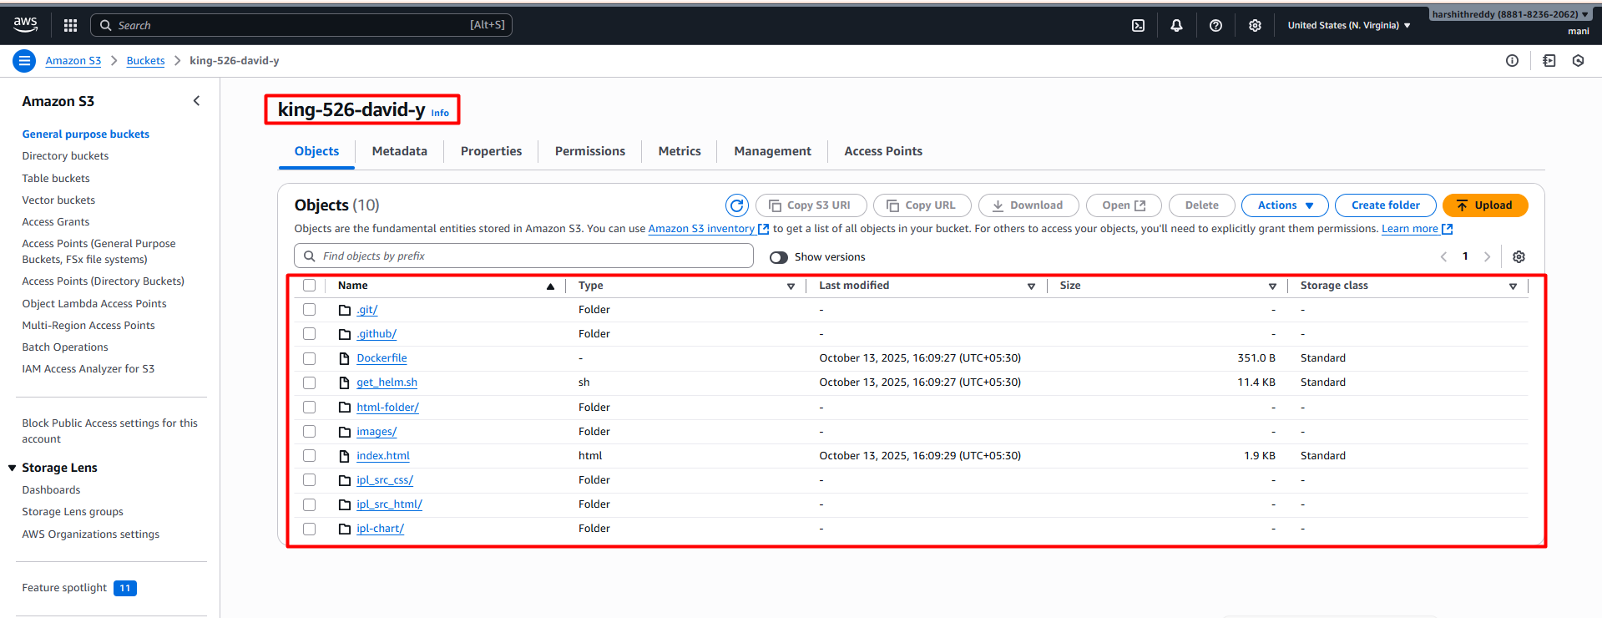

* Get the object URL n access the app on browser

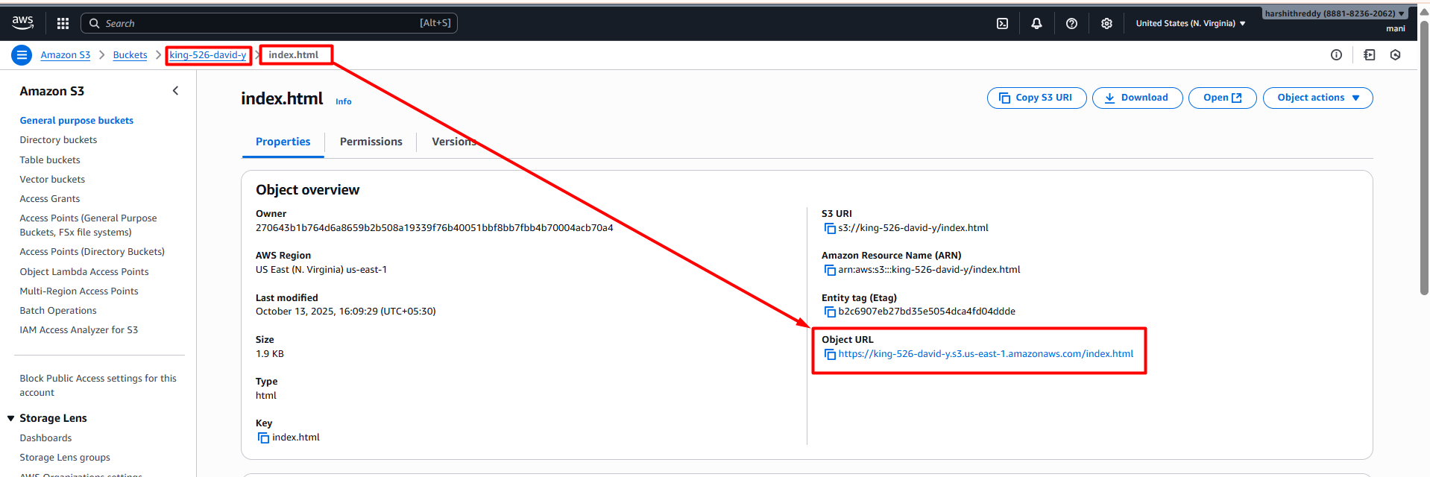

* Able to access the app



* **Now let’s deploy a node.js app fronted to an s3 bucket**
* Same as usual steps just need to create a file called “.github/workflows/deploy.yml” in repo root directory and provide required credentials in GitHub actions secrets.

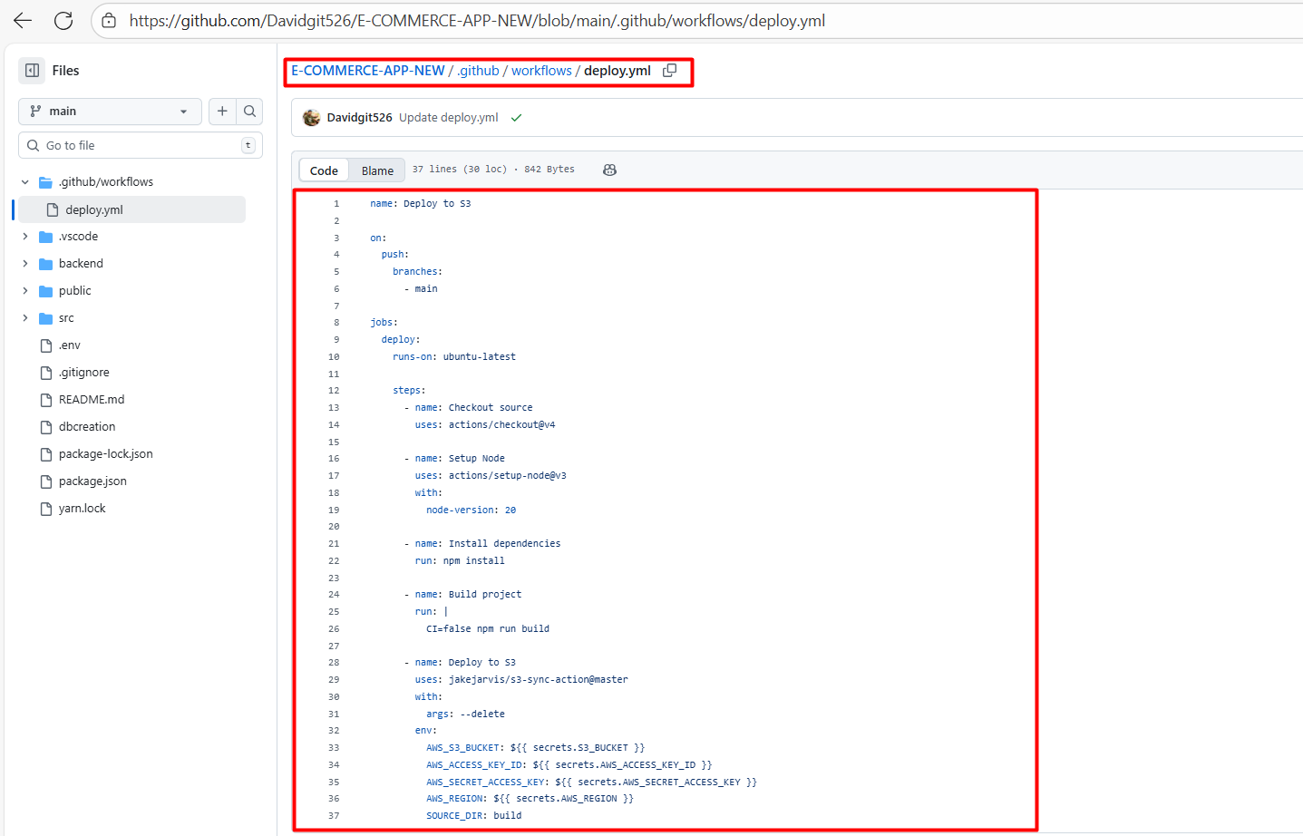

* Below is the script for ci GitHub Actions

name: Deploy to S3

on:

push:

branches:

- main

jobs:

deploy:

runs-on: ubuntu-latest

steps:

- name: Checkout source

uses: actions/checkout@v4

- name: Setup Node

uses: actions/setup-node@v3

with:

node-version: 20

- name: Install dependencies

run: npm install

- name: Build project

run: |

CI=false npm run build

- name: Deploy to S3

uses: jakejarvis/s3-sync-action@master

with:

args: --delete

env:

AWS_S3_BUCKET: ${{ secrets.S3_BUCKET }}

AWS_ACCESS_KEY_ID: ${{ secrets.AWS_ACCESS_KEY_ID }}

AWS_SECRET_ACCESS_KEY: ${{ secrets.AWS_SECRET_ACCESS_KEY }}

AWS_REGION: ${{ secrets.AWS_REGION }}

SOURCE_DIR: build

* GitHub actions workflow

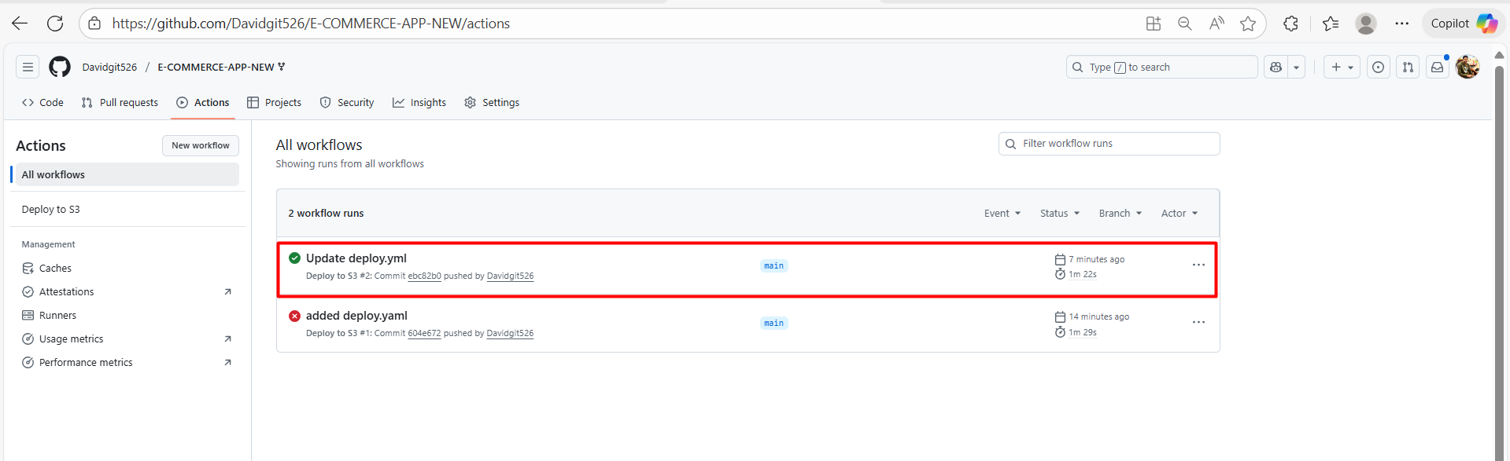

* App was deployed successfully into s3 bucket

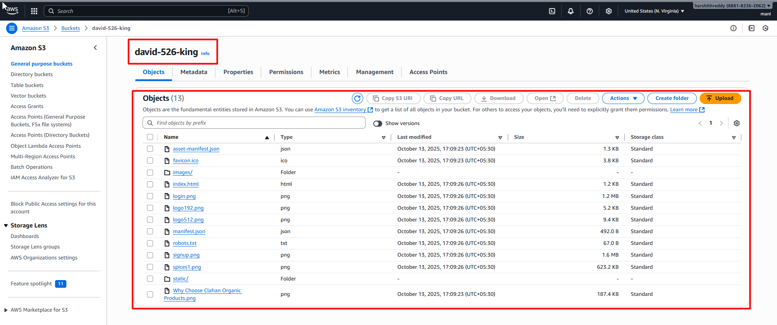

* Click on index.html go to properties get the object URL

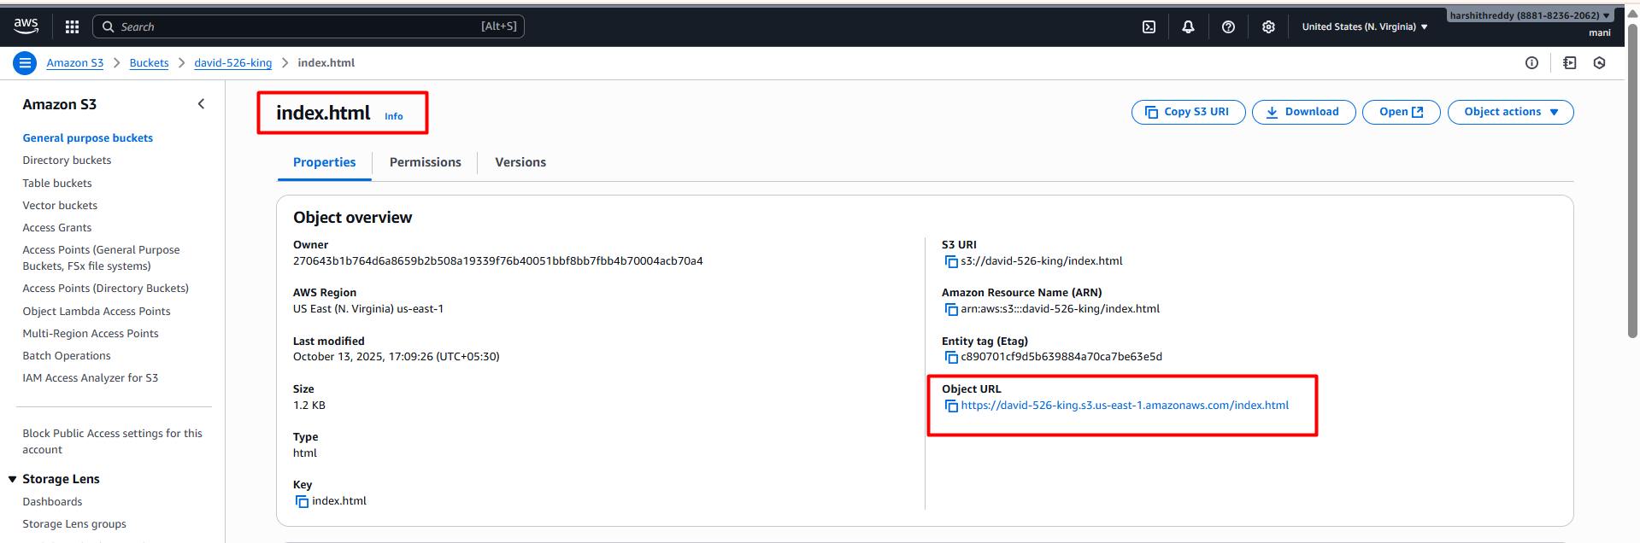

* Able to access the app on browser successfully



**🧱 Full Script Explained**

name: Deploy to S3

* **What it is:** The name of your GitHub Actions workflow.
* **Why:** It’s how this pipeline appears in the GitHub Actions tab (so you can identify it easily).
* **Purpose:** Label your automation workflow for clarity.

on:

push:

branches:

- main

* **What it is:** This defines the **trigger event**.
* **Why:** You want the deployment to happen **automatically** every time you push code to the main branch.
* **Purpose:** This ensures **continuous deployment** — each update to main automatically rebuilds and redeploys your site to S3.

jobs:

deploy:

runs-on: ubuntu-latest

* **What it is:** This starts a **job** called deploy.
* **Why:** GitHub Actions runs your steps inside a temporary **virtual machine (runner)**.
* **runs-on: ubuntu-latest** → Tells GitHub to use a fresh **Ubuntu Linux server** environment.
* **Purpose:** Provides an isolated environment to build and deploy your app (like a mini cloud VM).

**🪜 Steps — the CI/CD pipeline**

Each - name: under steps: is an **action step** executed sequentially.

- name: Checkout source

uses: actions/checkout@v4

* **What it is:** This step pulls your repository’s code into the workflow environment.
* **Why:** By default, the GitHub runner doesn’t have your code; this downloads it.
* **uses: actions/checkout@v4** → An official GitHub Action for cloning the repository.
* **Purpose:** Make your source code available so later steps (like npm install) can run on it.

- name: Setup Node

uses: actions/setup-node@v3

with:

node-version: 20

* **What it is:** Installs a specific version of Node.js in the workflow.
* **Why:** Your project (React app) needs Node.js to run commands like npm install and npm run build.
* **node-version: 20** ensures you’re using Node 20 (compatible with your React Router).
* **Purpose:** Prepare the environment for JavaScript dependency installation and building.

- name: Install dependencies

run: npm install

* **What it is:** Runs npm install to install all dependencies listed in your package.json.
* **Why:** The runner starts clean each time, so it needs to download your app’s required libraries.
* **Purpose:** Set up all project dependencies (React, Redux, etc.) before building.

- name: Build project

run: |

CI=false npm run build

* **What it is:** Runs your build command to compile the React app for production.
* **npm run build** → Creates an optimized version of your app in the build/ folder.
* **CI=false** → Prevents warnings from being treated as errors (important in CI environments).
* **Why:** The S3 bucket will host the **static files** (HTML, JS, CSS) produced here.
* **Purpose:** Generate the files that will be uploaded to your S3 bucket for hosting.

- name: Deploy to S3

uses: jakejarvis/s3-sync-action@master

with:

args: --delete

env:

AWS_S3_BUCKET: ${{ secrets.S3_BUCKET }}

AWS_ACCESS_KEY_ID: ${{ secrets.AWS_ACCESS_KEY_ID }}

AWS_SECRET_ACCESS_KEY: ${{ secrets.AWS_SECRET_ACCESS_KEY }}

AWS_REGION: ${{ secrets.AWS_REGION }}

SOURCE_DIR: build

Let’s break this important part down 👇

**🧰 What this does**

* **uses: jakejarvis/s3-sync-action@master**  
  → A prebuilt GitHub Action that uses AWS CLI to **sync files** from your local build/ directory to your **S3 bucket**.

**⚙️ args: --delete**

* **What it means:** Remove old files from S3 that no longer exist locally.
* **Why:** Keeps your S3 bucket clean and up-to-date with your latest build.

**🔐 Environment variables (env:)**

These come from **GitHub Secrets**, which you added under  
Settings → Secrets and variables → Actions.

| **Variable** | **Purpose** |
| --- | --- |
| AWS_S3_BUCKET | Your target S3 bucket name (e.g., king-526-david) |
| AWS_ACCESS_KEY_ID | IAM user’s AWS access key for authentication |
| AWS_SECRET_ACCESS_KEY | IAM user’s secret key for authentication |
| AWS_REGION | AWS region of your bucket (e.g., us-west-2) |
| SOURCE_DIR | Folder to upload (build folder from your React build) |

**🧩 Overall Purpose**

This pipeline achieves **fully automated deployment**:

1. Triggered whenever code is pushed to main.
2. Builds your React app.
3. Syncs (uploads) the build output to your S3 bucket.
4. S3 instantly serves the new version of your site.

✅ **In short:**

| **Stage** | **What happens** | **Why** |
| --- | --- | --- |
| on.push | Detects changes in main branch | Start CI/CD |
| checkout | Gets source code | Needed for build |
| setup-node | Installs Node.js | Run npm commands |
| install | Installs dependencies | Prepare environment |
| build | Compiles app | Create deployable files |
| deploy | Uploads to S3 | Publish website |